ay 2004

******#*#####*#**##2-E)iGiT 303

Breck H. Camp CML PO Box 47070 Atlanta GA 30362-0070

security F-roressionais

**GuroaLok*? XU1 Electronic Safe lock,_ Defeating an SGG 6561 on an %Jotd Yorksafe, the Schlage Cobra jrf0^tand-Alone EflC device, cmend-useF$&fl on Strattec’s Vt v new CodeSeeker,**

**. Unsticking Stuck Tumblers, plus the Curious Curator *^acks Down H Buck 8 mcRofjfcrts mortise Lock!**

up f^jn^xplosiuftiSti

**|y ClaiK L Cohen, CtfAy**

spam *pvuwm\**

SECTIOn: TUEJCOnSUmERrS * •

GUIDE TO BUVinG fl SAFE _

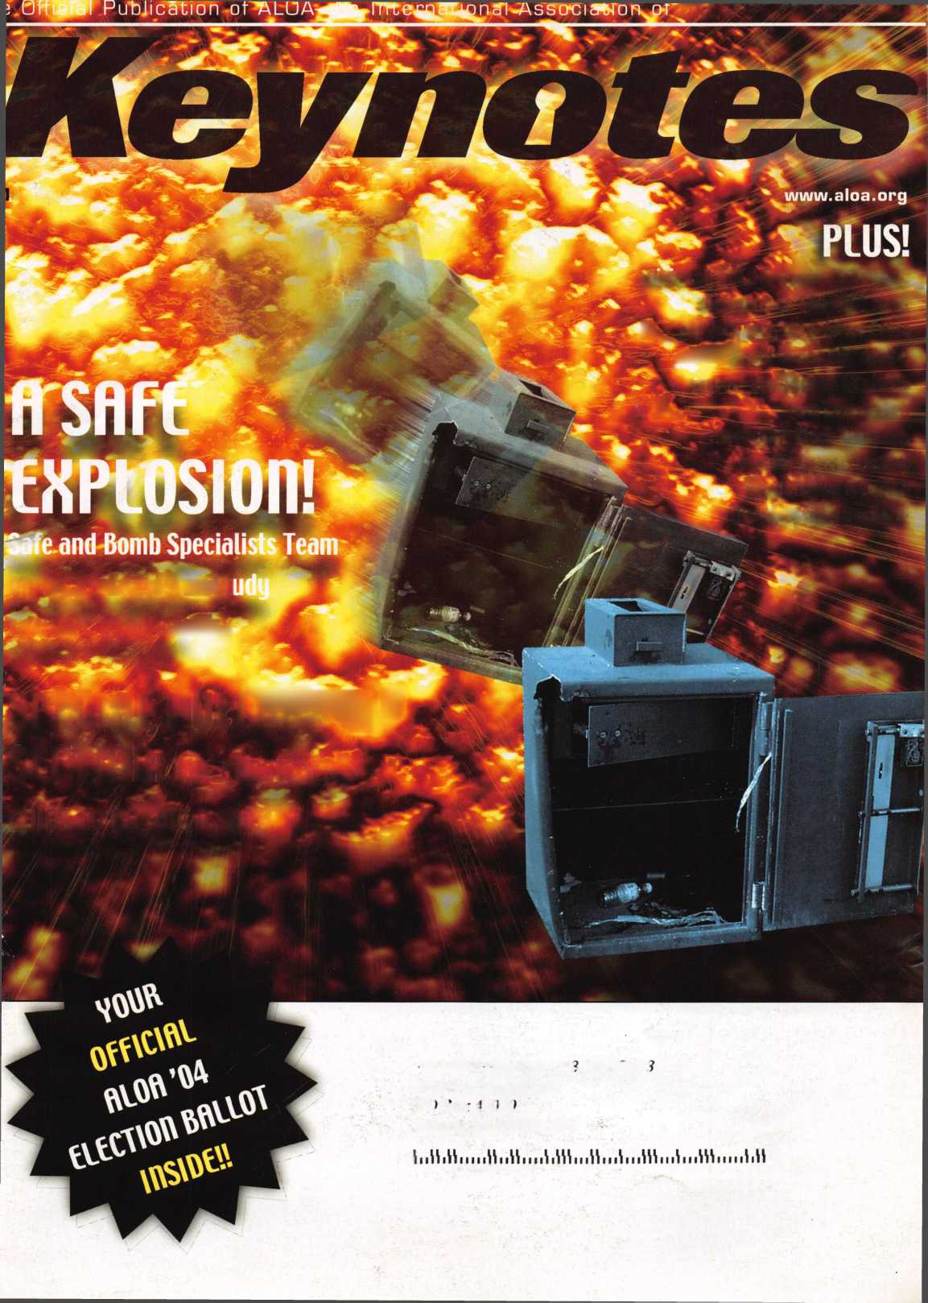

introducing **CODE-SEEKER.**

**NOT JUST A TOOL A MONEY-MAKING MACHINE.**

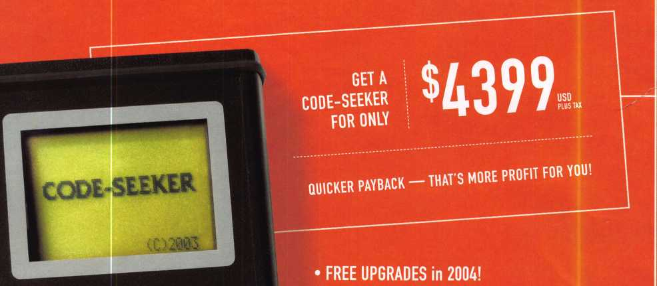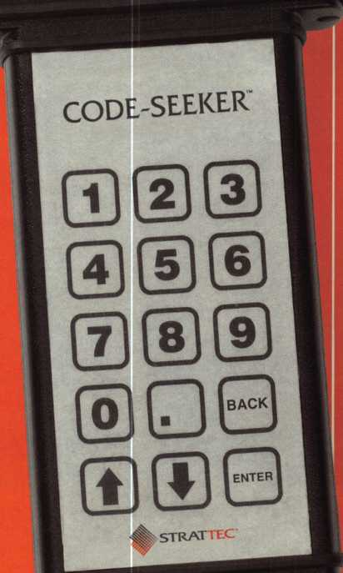

* **An UPGRADE SUBSCRIPTION of only $499 per year  
  in 2005 and 2006!**

**•OFFSET THAT UPGRADE FEE.**

**Get $1 credit toward the subscription fee for every  
STRATTEC transponder key purchased through an**

**authorized STRATTEC distributor! (Up to $499: no cash back value.)**

* **24-7 customer service and support!**
* **A name you can trust in automotive  
  lock technology!**

**CALL 414-247-3333 TO ORDER.**

ASK FOR CODE-SEEKER SALES.



]

***VISA***



**CODE-SEEKER”**

*hL*



**strattecXL**

**ONE SOURCE. MANY SOLUTIONS.**

Part #708884

**PROFIT FROM TECHNOLOGY.**

**FORD TRANSPONDER KEYS FROM STRATTEC.**

**YOUR OEM KEY SOURCE.**

**598333**

**Ford Crown Victoria 1998-2002 Ford Excursion 2000+**

**Ford Expedition 1998-2001 Ford Explorer 1998-2000 Ford F-Series Pick-up 1999+ Ford Mustang 1996+**

**Ford Ranger Pick Up 1999-2000 Ford Taurus LX/SHO 1996-1999**

**Ford Windstar 1999-2000 Lincoln Blackwood 2002 Lincoln Continental 1998-2002 Lincoln Navigator 1997-2002 Lincoln Town Car 1998-2002 Mazda Pick-up 1999-2000 Mercury Sable 1996-1999 Mercury Grand Marquis 1998-2002 Mercury Mountaineer 1998-2000**

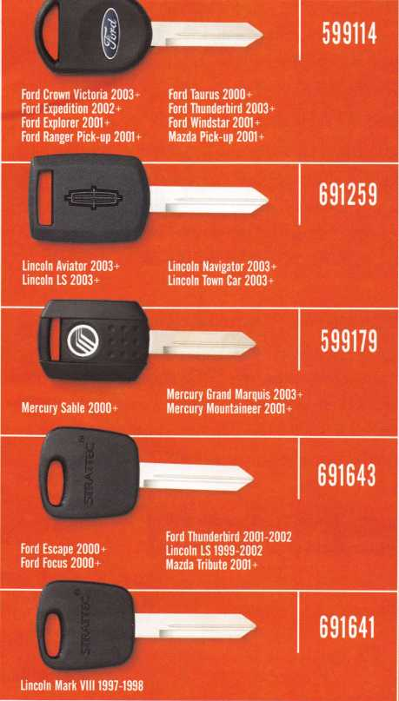

STRATTEC

**FOR MORE INFORMATION, CONTACT YOUR DISTRIBUTOR.**

You need it When?

**How about now!? :-)**

ClearStar Security , Network

Another Special  
Value-added Benefit to your

ALOA Membership! Click here

|  |  |  |
| --- | --- | --- |
|  | f >  [www.clearstar.com/ALOA](http://www.clearstar.com/ALOA)  k. ) |  |
|  |  | ) |

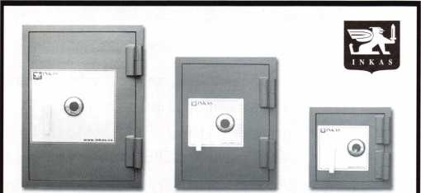

Now capture both the Residential and  
Business marketplace with our new  
inexpensive line of high security fire safes.

The SuperTuff is designed for businesses and homes needing more  
burglary protection without the intimidating price and cost.

Steel reinforced composite construction; one hour fire rating;  
expandable fire gasket; U.L. Group 2 combination lock; high quality  
adjustable hinges; 3 way boltwork (on 3219+); dual and electronic  
locking available; optional glass relocking system.

Custom interiors and colors available.

To become a distributor for one of North America's  
fastest growing safe manufacturers, please contact us.

For a full list of our current and future products, please visit our website.

1-877-913-7233 • [WWW.INKAS.CA](http://WWW.INKAS.CA)

presidential

viewpoint

As you are receiving and reading this edition of Keynotes, your ALOA  
Board is in full preparation for its spring meeting in Nashville, TN.  
During the past several months, your directors have been preparing  
the reports and discussion topics that will make up the agenda for  
this meeting.

The topics for discussion come from several sources. These items may  
be generated by the Board members but, often they are ideas formulat-  
ed by the members themselves. (That is, ideally, the way the association  
should work.) The directors are the mouthpieces for the membership. The

most effective way for a member to participate in the association and influence its direction is to  
express his or her thoughts and ideas to the representatives. The directors have been making a  
concerted effort to visit regional trade shows and solicit the ideas of members.

I have also been out and about and have encouraged people to contact me with any issues and  
concerns that they have about ALOA. I have been impressed with well-thought-out statements pre-  
sented to me by such members as Rick Dyer and Jeff Rosen of Colorado and, Dave Vandervelde  
of Michigan. These folks have commented on such topics as communication, education and the  
PRP, plus a shop certification program. This interaction assures that the board will strive to imple-  
ment what the membership wants!

This issue of Keynotes is our safe issue and I am proud that ALOA is partners with the best group  
of safe technicians in the world - SAVTA. I would like to congratulate SAVTA on putting on an  
outstanding show in Reno, in March. I also want to welcome and congratulate new SAVTA Presi-  
dent Ron Snively, CPS, while at the same time commending Skip Eckert, CML, for the tremendous  
job he did in leading SAVTA for many years. I also want to acknowledge the newest member of  
the SAVTA Hall of Fame, Henry Printz, CML. I think that Skip said it best when he said, "SAVTA  
might not exist today if not for the efforts of Henry."

Also, I am very relieved and proud to report that I can now add the initials "CPS" at the end of  
my name. The test was extremely difficult and I am grateful to Mike Oehlert for writing the book  
that helped me pass it!

In closing, I would like to remind everyone to be "SAFE" out there!

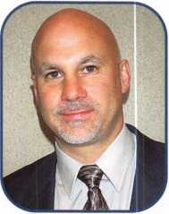

Sincerely,

William L. Young, CML, CPS

Keynotes • May 2004

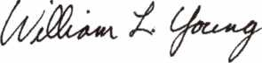

SafeData

Greg Perry, CML, CPS

Open up your library! SafeData allows you to find the information you've  
invested in, fast. This one program has over 8500 listings of magazine, books,  
ClearStar Security Network posts and my personal library. Each listing includes not  
only the book or magazine, the issue, the title, the author and the page, but it also  
lists the lock and the hand of the lock (when available). SafeData lists patent dates  
and other trivia that may help in identifying a container or lock.

SafeData also has picture folders representing over 90 different manufactures of  
safes and locks with over a thousand pictures. Some models include a text file giv-  
ing general information on size and relock locations. Plus you can add your own  
information and update it yourself or purchase the annual updates.

SafeData is available exclusively from ALOA. Normal price for this CD is $249.95.  
Price includes two installs! Put it on your desktop and your laptop.

Special Introductory offer

includes your first update!

$199.95

To order contact ALOA (800) 532-2562

f

e

a

t

u

res

Institutional Locksmithing 2004

12

A SAFE EXPLOSION!

**16**

Safe and Bomb Specialists Team Up  
for an Explosive Study

What do you find when you mix safe and vault techni-  
cians with bomb technicians? Meet Dave Fullarton, CPL,  
CPS, and his band of merrymen. The day-long exercise  
was held last year, in a quarry in a rural part of  
Maryland. Professionals from "both sides of the fence"  
were assembled. Here's what they found.

By Claire L. Cohen, CM

SAFES: Defeating an old York Safe  
(Why oh Why won't you open?)

Each time I run into a safe that won't open using some-  
one else's (or even my own) method and it doesn't  
work, I look at why. I also want to determine a better  
way if possible, or at a minimum, determine where I  
went wrong. There are times I feel frustrated and ques-  
tion my own abilities. I begin to wonder, "Why oh why  
won't you open?!" Then I get past the problem and the  
door swings. The frustration is gone and elation kicks  
in. It is such a rush. Now I'm ready for my next  
frustrating opening!

BY GREG PERRY, CML, CPS

***20***

Greg's Corner: XLN and the Gun Safe

I've used and installed several different electronic safe  
locks, but I've always been a bit shy about using them  
since they are generally not as reliable as mechanical  
locks. Over the last year, I've been watching the posts  
on the SAVTA web site ([www.savta.org](http://www.savta.org)) about  
GlobaLok's XLN. No one has reported a lock failure!  
I've spoken with several other safe technicians who use  
the XLN, and they sing its praises. Now it's my turn to  
try one.

BY GREG PERRY, CML, CPS

**Departments**

|  |  |  |  |
| --- | --- | --- | --- |
| Executive... | 5 | Legislative |  |
| Applicants | 6 | Update | 38 |
| Calendar... | 8 | Classifieds.... | 40 |
| Curious |  | Associate |  |
| Curator ....Back Page | | Members | 42 |

Visit our website



ACCESS CONTROL: THE SCHLAGE COBRA



Caution: Those chilling snake eyes are watching! The  
Schlage Cobra is an attractive, battery-powered elec-  
tronic lockset that is easy to install, maintain and pro-  
gram. The Cobra is available in a cylindrical or  
mortise lockset. We will take a closer look at the  
cylindrical version.

By Dave Thielen, CML

LOCK BASICS: UNSTICKING  
STUCK TUMBLERS

Our focus is on automotive applications, because the wafer design has always been popular with cars. At this point, virtually all vehicles use wafer locks. The problem we are concerned with is tumblers that either stick or otherwise become nonfunctional. Within the automotive environment, these problems are common. Here's how to solve them.



AUTOS: Takin' it to the Streets: Tracking the Reception of Strattec's New Code-Seeker

With the introduction of STRATTEC Security Corporation's new product, CODE-SEEKER™, we want­ed to find out how the industry is receiving the new product. We visited Gene Schaed, owner of Apex Key & Lock in Racine, Wl, to find out just what the inside word is. Gene's been in the business for more than 34 years, and if anyone has an opinion on a new product, we're thinking it's him. Here's how our discussion went:

|  |  |  |  |
| --- | --- | --- | --- |
|  |  |  |  |
|  | Ad Index |  |  |
|  | A&B Safe | .33 |  |
|  | Adesco | .33 |  |
|  | Clearstar | 1 |  |
|  | Hickok Back Cover | |  |
|  | Hinge Doctor | ...41 |  |
|  | Inkas | 1 |  |
|  | Lockman | ...41 |  |
|  | Lockmasters | 9 |  |
|  | Professional Business Products | 9 |  |
|  | SafeData | 3 |  |
|  | Strattec Inside Front Cover | |  |
|  | Turn 10 | ...41 |  |
| L |  |  | A |

at [www.aloa.org](http://www.aloa.org)

executive

Volume 50, Issue 5

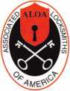

Additional contact information for the ALOA Board and most Keynotes authors is  
available through "Locksmith Search'" on the ALOA Web site- [www.aloa.org](http://www.aloa.org) or by  
contacting the ALOA office at 3003 Live Oak Street; Dallas, TX 75204; (800)532-2562;  
FAX (214)827-1810; e-mail [aloa@aloa.org](mailto:aloa@aloa.org).

|  |  |
| --- | --- |
| Editor  Jim DeSimone | [editor@aloa.org](mailto:editor@aloa.org) |
| Technical Editor  David Lowell, CML, CMST ... | [david@aloa.org](mailto:david@aloa.org) |
| Editorial Advisor  John Cannon, CML | [secretary@aloa.org](mailto:secretary@aloa.org) |
| Art Director  Betty Henderson | [betty@aloa.org](mailto:betty@aloa.org) |
| Advertising Sales  Kim Hammond | voice: 817-645-6778  Fax: 817-645-7599 e-mail: [adsales@aloa.org](mailto:adsales@aloa.org) |

Executive Director

Charles W. Gibson, Jr., CAE [charlie@aloa.org](mailto:charlie@aloa.org)

Convention & Meetings Manager

Jo Anne Mims

PRP/Education Manager

David Lowell, CML, CMST

Contributors

Jerome Andrews, CML  
Paul Chandler, CRL  
Claire Cohen, CML  
Brian Costley, CML, CMST  
Eric Costley, CRL

[joanne@aloa.org](mailto:joanne@aloa.org)

[david@aloa.org](mailto:david@aloa.org)

Ray D'Adamo, CML Sal Dulcamaro, CML Billy Edwards, CML Dan Graffeo, CRL,CMST Jim Hancock, CRL

Operations/Membership Manager

Mary May [mary@aloa.org](mailto:mary@aloa.org)

Government Relations Manager

Paul Kanitra [paul@aloa.org](mailto:paul@aloa.org)

IT Operations Manager

Greg Jackson [greg@aloa.org](mailto:greg@aloa.org)

Comptroller Kathy J. Romo

Membership Coordinator Shelly Jett

Convention & Meetings Assistant Karen Lyons

PRP/Education Coordinator Hope Rodriguez

Accounting Coordinator Bryan Dease

Mail Room Coordinator Kevin Wesley

Receptionist Cliff White

AJ. Hoffman, CML Jeff Nunberg, CML, CMST Randy Simpson, CML Robert Stafford, CML Dave Thielen, CML

Greg Perry, CML,CPS Tom Seroogy Charles Stephenson, CPS Dennis Watanabe, CML, CMST

Mission Statement: The Associated Locksmiths of America, Inc. is dedicated to enhancing the professionalism, education and ethics among locksmiths and those in related sectors of the physical security industry. With approximately 10,000 members in the United States, Canada and the freeworld, ALOA is poised to help members obtain the knowledge, the strength, and the confidence to perform their role in the physical security field with pride and dignity. But it is only through active involvement and participation that ALOA can fully achieve its potential—and can help members to achieve theirs.

Policies: Keynotes® is the official publication of the Associated Locksmiths of America, Inc. (ALOA). Keynotes® acts as a moderator without approving, disapproving, or guaranteeing the validity or accuracy of any data, claim, or opinion appearing under a byline or obtained or quoted from an acknowl­edged source. The opinions expressed by the authors do not necessarily reflect the official views of ALOA. Also, appearance of advertisements and new products or service information does not constitute an endorsement of products or services featured by the Association. The Association does not accept responsibility for the inaccuracy of any data, claim, or opinion appearing in this publication, due to typographical errors on the part of the authors, Association staff or its agents.

Editor's Note: This publication is designed to provide accurate and authoritative information in regard to the subject matter covered. It is provided and disseminated with the understanding that the publisher is not engaged in rendering legal or other professional services. If legal advice and other expert assistance is required, the services of a competent professional should be sought.

Authors' Payment: Payment for eligible submissions to Keynotes will be based on the following criteria: topic, time spent and past contributions. Authors who regularly submit to Keynotes® are generally paid a higher rate. The latter is especially true of authors who write to fit specific editorial needs and submit said copy by Keynotes® deadlines. As a general guideline: Average payment for a 750 word, business or light' technical article would be $200. Payment for a 1500 word article involving significantly higher time and research efforts would be $400.

Payment will not be offered for articles submitted by ALOA employees or members of the ALOA Board of Directors (unless material is of a technical nature), nor for articles submitted by a company that promote that company's products or services. ALOA reserves the right not to pay for articles sub­mitted by an individual(s) that promote a particular company's products or services.

Disclaimer: The Associated Locksmiths of America, Inc., (ALOA), reserves the right to refuse any article for any reason. Additionally, ALOA reserves the right to edit, amend or modify any article submitted for publication in order to preserve technical accuracy, clarity, fairness or grammatical cor­rectness. ALOA will make the best efforts to notify the author of any changes. The extent of ALOA's liability for any article or information contained therein will be a notice of correction or retraction in the next possible issue.

Keynotes® (ISSN 0277 0792) is published monthly except for the combined June/July issue by The Associated Locksmiths of America, Inc., 3003 Live Oak St., Dallas, TX 75204-6186. Telephone: (214) 827-1701; FAX (214) 827-1810; e-mail [aloa@aloa.org](mailto:aloa@aloa.org). Subscription rates for members—$15.00 per year. Periodical class postage paid at Dallas, Texas. POSTMASTER: Send address changes to: Keynotes, 3003 Live Oak St., Dallas, TX 75204-6186. © Copyright 2003, All rights reserved. No part of the contents may be reproduced or reprinted in any form without prior written permission of the publisher.

President

William L. Young, CML  
(610)647-5042  
[president@aloa.org](mailto:president@aloa.org)

Secretary

John D. Cannon, CML  
(703) 960-6413  
[secretary@aloa.org](mailto:secretary@aloa.org)

Directors, Northeast

Robert E. Mock  
(856) 863-0710  
[nedirector@aloa.org](mailto:nedirector@aloa.org)

Peter Sarailian, CRL  
(973)890-9797  
nedirector@aloa .org

William L. Young, CML  
(610) 647-5042  
ned i rector@a loa. org

Directors, Southeast

Tom Gillingham, Jr., CML, CPS  
(615)2640747

[sedirector@aloa.org](mailto:sedirector@aloa.org)  
Ken Kupferman, CPL  
(813)961-5784  
sed i rector@a loa. org

Directors, North Central

Mark E. Blum, CML, CPS  
(517) 482-5809  
ncd i rector@aloa. org

John Soderland, CML, CMST  
(414) 327-5625  
ncd i rector@aloa. org

Director, South Central

CD Lipscomb, CML, CPS  
(903)874-3522  
scd i rector@a loa. org

Directors, Southwest

Gordon R. Racine, CML  
(719) 384-4707  
[swdirector@aloa.org](mailto:swdirector@aloa.org)

Julie McCluney, CRL  
(714) 636-5652  
swd i rector@a loa. org

Director, Northwest

Scott L. Henke, CPL, CPS  
(907) 248-3785  
n wd i rector@a loa. org

Director, European

Hans Mejlshede, CML  
(453)539-3939  
eurdirector@aloa .org

Director, Asian

JoeJ. Lee, CRL  
(215)289-2404  
[asiandirector@aloa.org](mailto:asiandirector@aloa.org)

Director, Associate

Paul M. Justen  
(800)333-6953  
[asdirector@aioa.org](mailto:asdirector@aioa.org)

Trustees

[trustees@aloa.org](mailto:trustees@aloa.org)

Randy Simpson, CML  
(281)240-5959

JohnJ. Greenan, CML, CPS  
(773) 486.2030

Dallas Brooks  
(334) 826-8990

Past Presidents

2001-2002 Randy Simpson, CML  
1999-2001 John Greenan, CML, CPS  
1997-1999 Dallas C. Brooks  
1995-1997 David Lowell, CML, CMST  
1993-1995 Breck Camp, CML  
1991-1993 Henry Printz, CML  
1989-1991 Evelyn Wersonick, CML, CPS  
1987-1989 Leonard Passarello, CPL  
1985-1987 Joe Jackman, CML  
1983-1985 Stanley Haney, CPL  
1981-1983 Louis LaGreco, CPL  
1979-1981 John Kerr, RL  
1977-1979 Clifford Cox, CML  
1974-1977 Charles Hetherington  
1972-1974 Gene Laughridge  
1970-1972 William Dutcher, RL  
1968-1970 Constant Maffey, RL  
1966-1968 Harold Edelstein, RL  
1964-1966 William Meacham  
1962-1964 Robert Rackliffe, CPL  
1960-1962 Edwin Toepfer, RL  
1956-1960 Ernest Johannesen

Keynotes • May 2004

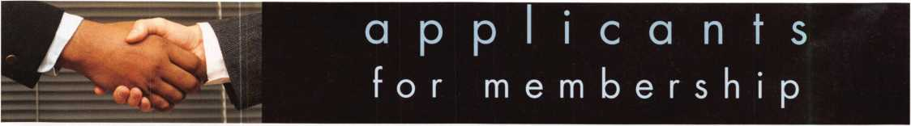

|  |  |  |  |  |  |  |
| --- | --- | --- | --- | --- | --- | --- |
| AR | Chicago | MN | 1 1 | TX | 1 1 | Bahamas |

Harrison

Don Gehr

Phoenix

Charles L. Moore

Sponsor: William Lee CRL

Danville

George F. Kenney

Sponsor: Gregory L. Perry CML, CPS

Mountain View

Matt D. Resnick

Sponsor: Frederick P. Collier Santa Maria

Michael Head

William E. Demuth II

Sponsor: William E. Sherlock Morris

Daniel Chesharek

Sponsor: Mark C. Backhus

Bedford

Jacob Murdy

Fort Wayne

Jacob Carey

Sponsor: Jeremy B. Rodocker CML, CPS

Jarrod M. Carey

Yuba City

Joe McNair

Washington

Patrick Pettis Anthony Anderson

Sponsor: James E. Anderson

Wilmington

Bryan L. Murray

Bradenton

Marvin P. Miller Jr

Sponsor: Kent M. McFarland CRL

Lonnie D. Lewis Jr

Sponsor: KentM. McFarland CRL Margate

Khamrajh Hargobin

Sponsor: Antonio L. Polerecky Miami

Craig Collins

Atlanta

Kirk T. Viator

Flowery Branch

Robert Stys

Sponsor: James S. Mayes Savannah

Marlon S. Green

Victor

Douglas Aslin

Sponsor: Brooke P. Berry CRL

Berkeley

David Martin

Sponsor: James B. Kubin CML

Wichita

Eric Vail

Denham Springs

Michael Hassler

Boston

William Anderson

Sponsor: David Ai. Troiano

Jennifer Cleveland

Sponsor: David M. Troiano Brighton

Donald Spencer

Sponsor: David M. Troiano Chelsea

Matthew Mondello

Sponsor: David M. Troiano Dedham

Ryan Huntoon

Sponsor: David M. Troiano

George Huntoon

Sponsor: David M. Troiano Franklin

Henry M. Bryson

Sponsor: David M. Troiano Jamaica Plain

Paul H. Cummings

Sponsor: David M. Troiano Malden

Mario Barletta

Sponsor: David M. Troiano Medford

Shawn O'Neil

Sponsor: David M. Troiano Salem

Jackson R. Sheehy

Sponsor: David M. Troiano Somerville

Matthew Garelick

Sponsor: David M. Troiano

Cannon Falls

Travis A. Blomberg

Sponsor: Jerrold G. Antoon RL, CPP Walker

Kent Reeve

Columbia

J W. Lewis

Canton

Margie Winters

Sponsor: Michael W. McCorkle CRL

Aberdeen

Robert L. Scarboro II

Sponsor: Downie W. Dowless Jr, CML, CMS

Maplewood

Ernest P. Valcourt

Las Vegas

Dennis Imhoff

East North port

John Montill

Fresh Meadows

Shin-An Lin

Sponsor: Buttong C. Cheung New York

Yosef U. Kadosh

Plattsburgh

Paul Stearns

Sponsor: Terance T. Campbell CPL

Northfield Center

**William E. Tesar**

Sponsor: Ronald G. Betschman CML

Pittsburgh

Lorine Flower

Yard ley

Frank Urban

Southfield

Robert E. Banker Sr

Sturgis

Corey J. Aulbach

Hilton Head Island

Richard K. Melton

Murfreesboro

Wallace E. Bernard

Sponsor: Bruce J. Tarbet CML, CPS

Dallas

Douglas R. Cannon

Sponsor: Robert A. Ashmore

David Z. Love

Sponsor: Randy L. Hutchison CRL

Gregory D. Richardson

Sponsor: Randy L Hutchison CRL Denton

Bryan K. Popham

Euless

Tom Person

Houston

Satchi David Joel Ramirez

Sponsor: Starlin M.

Clifford Jr, CML Marble Falls

Philip M. Anderson

Sponsor: Loren G. Marshall Marshall

James Murrell

Sponsor: Ralph O. Warren CML Pasadena

Rolando L Palomares

Sponsor: Anthony W. Ball CRL Spring

James E. Hall

Arlington

William Walker

Sponsor: Michael B. Groves Ashland

Brad Hamaker

Sponsor: Mark K. Brooking Newport News

Edmund E. Blanchard Jr Brenda L. Blanchard

Sterling

Adam Young

White Stone

Brian Conboy

Winchester

Doug Willhite

Wood invi lie

Gordon Mitchell

Altoona

Ronald W. McCarty

Sponsor: William T. Beranek

Cheyenne

Richard D. Hirsch

Rock Springs

Vance Petersen

Nassau

Dallas L Roberts

Sponsor: Martha M. Albury

Canada

Kirkland Lake, ON

Michel Larose

Palmerston

Timothy D. Brandt

Ecuador

Quito Pichincha

Luis Vinicio Espinoza

Hitchin Herts

Timothy Lawrence

London Docklands

Terry Watts

Sponsor: Rene Andreasen Romford Essex

Desmonde Jarman

Sponsor: Ken Dale

Turnu

Pontus Eggert

Sponsor: Rene Andreasen

Dublin

Desmond Carrick

Sponsor: Westley Lowndes

Japan

Fukuishi Fukuiken

Toshinobu Ogawa

Sponsor: Makoto Yoshizawa CRL Tsu Mie

Tadashi Hirano

Sponsor: Yoshihisa Baba

Cheonan Chung Nam

Yong-Jin Jang

Sponsor: Nam Dong Un Cheonan, Chung Nam

Du-Kyun Na

Sponsor: Nam Dong Un Segwipo, Jeju-do

Sang-woo Hyun

Sponsor: Dong-Hoon Song Seoul

Myung Sik Ko

Sponsor: Nam Dong Un

Bou-Whoan Na

Sponsor: Dong-Hoon Song Sang-Pil Lee

Sponsor: Nam Dong Un Ulsan, Kyungnam

Kang-ok Lee

Sponsor: Nam Dong Un

These applicants are scheduled for clearance as members of ALOA. The names are published for member review and comment within 30 days of this Keynotes issue  
date, respectively, to ensure applicants meet standards of ALOA's Code of Ethics. Protests, if any, should be addressed to the Membership Department and must be  
signed. Active Membership applicants (a) have worked in the industry two or more years. Allied Membership (AL) applicants are not locksmiths, but work in a security-  
related field. Apprentice Membership (AP) applicants have worked in the industry less than two years.



Get ready for ALOA  
2004 - the biggest  
security event in the  
world! ALOA will  
land in Baltimore's  
famed Inner Harbor  
to stage classes,  
workshops and

Get It... exhibits that will help

Toncthcr ^ou s^ne *n

marketplace.

4M-04I ’ 0

fe-Al-TlWORE, Wp

get *it... together*

The ALOA Convention and Security Expo • Baltimore Convention Center • July 19-25, 2004  
(800)532-ALOA(2562) • [convention@aloa.org](mailto:convention@aloa.org) • [www.aloa.org](http://www.aloa.org)

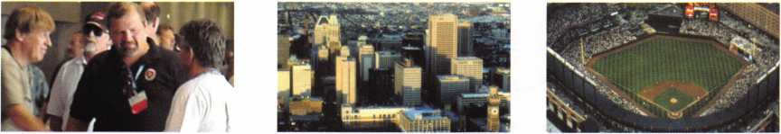

JUNE I MAY APRIL

upcoming events

7

1

22

Minnesota Chapter 16-1 8 East Coast Regional

Regular Meeting Locksmith Convention

Dave Nissen Somerset, New Jersey

[mnchapternews@aol.com](mailto:mnchapternews@aol.com)

5 Minnesota Chapter Regular Meeting Dave Nissen

LASA • San Antonio Service and Combo Changing Contact Steve Morse Phone #512-353-8615 topnotch@thrifty. net

Ok. Master Locksmith Assoc. Holiday Inn Select • Tulsa, OK "Defense Against Methods..." Contact: Scott Hancock 405-557-7422

24-25 Alabama Locksmith Association Membership Meeting, Dinner, Discussion & Seminars Call 1-800-893-5487

9.-23. LOCKSMITHS CONVENTION 12 New York Master Locksmiths' Assoc. ESTREL HOTEL BERLIN Monthly Meeting

Tel: +49 030 6831-22522 NYC/Long Island Area

Fax: +49 030 6831 -2345 718 274-6930

mail: [reservierung@estrel.com](mailto:reservierung@estrel.com)

6

North Jersey Master Locksmiths Association

1 Oth Annual Flea Market Quality Inn • Lindhurst, NJ Nick Hart: 201/944-7547

10-13 International Association of Investigative Locksmiths Educational Conference Holiday Inn, Columbia, MD 410-674-7721



13 Southern Lock & Suppply Trade Show St. Petersburg, FL 727-541-5536

26

LASA

Safety Deposit Boxes Contact Steve Morse Phone #512-353-8615 [topnotch@thrifty.net](mailto:topnotch@thrifty.net)

**UPCOMING PRP SITTINGS**

|  |  |
| --- | --- |
| 5/7/2004 | 6:00 PM • Nashville, TN • TN Tool & MTLA  Jim Windman, CRL 615-837-1264 |
| 5/13/2004 | 8:30am • Dallas, TX • ALOA  Hope Rodriguez 800-532-2562x30 |
| 5/15/2004 | 5:00pm • Seattle, WA • KDL Hardware Supply, Inc. Julie Pilgrim (800)926-7716 |
| 5/21/2004 | 6:00pm • Fort Wayne, IN • Northern Indiana Chapfc Jeremy Rodocker, CML,CPS 260-459-1500 |
| 6/10/2004 | 8:30am • Dallas, TX • ALOA  Hope Rodriguez 800-532-2562x30 |
| 6/27/2004 | 8:00am • Reno, NV • Clark Security Products  Joan Emrick 619-718-7308 |
| 7/8/2004 | 8:30am • Dallas, TX • ALOA  Hope Rodriguez 800-532-2562x30 |
| 7/23/2004 | 6:00pm • Baltimore, MD • ALOA2004 Convention Hope Rodriguez 800-532-2562x30 |
| 8/12/2004 | 8:30am • Dallas, TX • ALOA |

|  |  |
| --- | --- |
|  | Hope Rodriguez 800-532-2562x30 |
| 9/9/2004 | 8:30am • Dallas, TX • ALOA  Hope Rodriguez 800-532-2562x30 |
| 10/3/2004 | 8:00am • Anaheim, CA • Clark Security Products Joan Emrick 619-718-7308 |
| 10/9/2004 | 8:00am • Omaha, NE • MINK Convention  Bernard Dobesh 308-381-4440 |
| 10/14/2004 | 8:30am • Dallas, TX • ALOA  Hope Rodriguez 800-532-2562x30 |
| 11/11/2004 | 8:30am • Dallas, TX • ALOA  Hope Rodriguez 800-532-2562x30 |
| 11/20/2004 | 8:00am • Atlanta, GA • Georgia Chapter of ALOA Kevin Wilson, CML,CPS 770-279-1161 |
| 12/9/2004 | 8:30am • Dallas, TX • ALOA  Hope Rodriguez 800-532-2562x30 |

Advertise with Weatherproof Safety Labels!

Lockout your  
competition

by placing your  
calling card on  
every door you  
service! Keep

your name in front  
of every customer  
with these Durable,  
Affordable Labels  
Call & Order Today  
1-800-355-6322

**(Actual Label Size 1 1/2x4 1/2)**

Professional Business Products

ALOA Associate Member

Check out our competitive prices on Invoices with two color ALOA  
logo, Repair Tags/Claim Checks, Business Cards, Door Hangers,  
Shirts, Hats, Pens, Key Tags, Magnets.

[www.pbp2000.com](http://www.pbp2000.com)

o

4J

3

***anti*** NASCAR

in

Lockmasters' PUREAuto  
Automotive Weekends  
is proud to add a  
NASCAR Race Package  
to our **October Pit Stop**this year.

2004 Pit Stops

May 22-23 - Buffalo, NY  
Oct. 1-3 - Talladega, AL  
Nov. 6-7 - Las Vegas, NV

Learn From The  
Industry Experts

Track 1 - Domestic Automotive  
Track 2 - Import Automotive  
Track 3 - High Security Automotive  
Track 4 - Automotive Transponders  
Track 5 - Key Generation  
Track 6 - Mechanical Safe Lock  
Track 7 - Electronic Safe Lock

Check out pureauto.com for  
complete track info & a  
registration form. Register  
early for discounts and assure  
your seat before they sell out.

800.654.0637

pureauto.com

**UPCOMING ACE CLASSES**

|  |  |  |  |
| --- | --- | --- | --- |
| 5/1-2/2004 | White River Junction, VT • Green Mountain Locksmiths Assn. Peter Deutsch 802-295-5242  Life Safety Codes Exit Devices & Exit Alarms | 9/18/2004 | Atlanta, GA • Georgia Chapter of ALOA  Kevin Wilson, CML, CPS 770-279-1161  PRP Prep Class |
| 5/15/2004 | Atlanta, GA • Georgia Chapter of ALOA  Kevin Wilson, CML,CPS 770-279-1 161  Small Format Interchangeable Core | 10/7-10/2004 | Omaha, NE • MINK Convention  Bernard Dobesh 308-381-4440  CPS Prep Class |
| 5/22 - 23/2004 | Fort Wayne, IN • Northern Indiana Chapter of ALOA |  | www. nebraska-locksmith .com |
|  | Jeremy B. Rodocker, CML,CPS260-459-l 500  Hollow Metal Doors & Frames Life Safety Codes | 10/12 - 16/2004 | Portland, OR • Pacific Locksmiths Association Tom Jones, CRL 503-842-2944 |
| 6/5/2004 | Randolph, MA • The Flying Locksmiths |  | 17 ACE Classes |
|  | Barry McMenimon, CRL 781-963-5080  High Security Cylindars with L-08 Prep | 10/20 - 24/2004 | Sturbridge, MA • Yankee Security Convention Jack Hobin 800-209-8266 |
| 7/18-25/2004 | Baltimore, MD • ALOA 2004 Annual Convention |  | 9 ACE Classes |
|  | DAVID LOWELL, CML, CMST 800-532-2562 XI 8 71  ALOA ACE CLASSES and Security Expo [education@ALOA.org](mailto:education@ALOA.org) 39 Seminars and Half Day Classes | 10/25 - 30/2004 | APPLETON, Wl Fox Valley Technical College Jerry Antoon P-920/735-2406  6 Day Basic Locksmithing Course |
| 8/22 - 28/2004 | Dallas, Texas • ALOA Continuing Education  8- Day Basic Locksmithing Course  David Lowell, CML, CMST  800-532-2562 x!8 [education@aloa.org](mailto:education@aloa.org) |  | Fox Valley Technical College F-920/735-2414 |

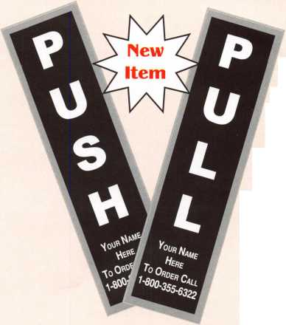

ALOA Elections 2004

**FOR THE OFFICE OF SECRETARY**

(Eligible to vote: All Active, Apprentice, Retired, Life and Associate members)

**FOR THE OFFICE OF NORTHEAST REGION DIRECTOR**

John Soderland, CML, CMST

My name is John Soderland and I am running for the position of ALOA Secretary. I will do my best to assure that the records for ALOA are main-

fc)j{ j,. ^ tained in an accurate and timely manner. I will do my best to assure that the

ALOA Board will fairly represent each member in accordance with the Governance Policy that was adopted by the membership in 1998 in n Nashville.I will do my best to assure that every member of ALOA will have a

\ 1 voice in our association. I realize that, if elected, I will not be representing a

sPec'fic region but that I will be representing every member regardless of where they live.

**FOR THE OFFICE OF**

**SOUTH CENTRAL REGION DIRECTOR**

(Eligible to vote: Active, Apprentice, Retired, and Life members whose business address is in Arkansas, Kansas, Louisiana, Missouri, Oklahoma, Texas):

C.D. LIPSCOMB, CML, CPS,

C.D. has worked in the physical security industry since 1974. He started out as an institutional locksmith for Navarro College in Corsicana, Texas. In addi­tion to physical security work, he has a working background as a construction engineer, carpenter, and contractor. Currently, Mr. Lipscomb operates a full service, retail storefront locksmith shop with multiple outside service vehicles in Corsicana, Texas. He is a member of ALOA, SAVTA, and five other local lock­smith associations. Mr. Lipscomb has served on the executive boards of sever­al of these organizations. In addition to managing a physical security busi­ness, Mr. Lipscomb is an ALOA certified instructor and currently teaches vari­ous locksmithing classes for locksmith associations.

VOTE FOR THREE (3) ONLY

(Eligible to vote: Active, Apprentice, Retired, and Life members whose business address is in Connecticut, Delaware,  
District of Columbia, Kentucky, Maine, Maryland, Massachusetts, New Hampshire, New Jersey, New York, Ohio,  
Pennsylvania, Rhode Island, Vermont, Virginia, West Virginia, APO New York):

Robert "Bob" Mock

Known to fellow professionals as the Frugal Locksmith, Robert Mock has been  
"on the road" in the security industry for more than 25 years. As a student  
and mentor, he has traveled to confer with other expert locksmiths from around  
the world. Coming from a unique perspective of both business owner and  
employee, Bob has accumulated a wealth of practical information that only  
experience can provide.

Mr. Mock has served as a member of the Board of Directors of the  
Greater Philadelphia Locksmiths Association. He has served as Chairman of  
the Board and held the position of President. He has also occupied the posi-  
tions of Vice President and Corresponding Secretary for the GPLA and he  
generally serves as their Ambassador of Goodwill.

Together with his GPLA membership, Bob is a charter member of the South  
Jersey Locksmiths Association, an honorary member of the National Locksmiths  
Association of Canada and a longtime member of the Associated Locksmiths  
of America. In addition, he is a Founding Member of the ALOA European  
Chapter. Among his other endeavors are serving on the board of the Gerald  
J. Connelly Memorial Library Foundation, functioning as Curator of the GPLA  
Library, writing articles for various trade publications and teaching classes.

The "Bobfather" as he has been dubbed by his cohorts, has been hon-  
ored by the Master Locksmiths Association of Great Britain; he has twice  
accepted the Herman C Henssler Jr. Memorial for Outstanding Effort and has  
received the Lee Rognon Award for Promoting Cooperation Among  
Associations.



For the last two years, Mr. Lipscomb has served the members of the South Central region of ALOA as Regional Director to the ALOA Board. Mr. Lipscomb believes in ALOA as a member-oriented organization. During his two year term, he has attended meetings at all but one local and state lock­smith association in the South Central region. Mr. Lipscomb will visit that one association before the end of this current term. During his term in office, Mr. Lipscomb has logged over twenty thousand travel miles and attended nearly 50 locksmith association meetings while in ALOA service.

CD Lipscomb is currently running for a second term as Director and asks that the members of the South Central region see fit to vote for him.

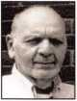

Peter Sarailian, CRL

Pete has been a locksmith for 28 years and an ALOA member since 1976. He's served as Treasurer of the Master Locksmith Association of New Jersey from 1994 until present and was president of that organization in 1987. Pete owned his own business from 1974 until 2000, when he sold it. he is cur­rently employed by Safemasters in Little Falls, NJ as material coordinator and inside tech.

**Proposed Bylaws Changes**

Proposed Bylaws Change #1 "That the bylaws Article V, Section 2, shall be changed to read - Election and Term of Office. The officers shall be elected by the voting members for a two year term. A per­son may serve as the President of the corporation for no more than one (1) term, and may serve as the Secretary for no more than three (3) consecutive terms. The President shall be elected in odd-numbered years and the Secretary in even-numbered years at a special meeting of the mem­bers. They shall serve until their successors have been duly elected and qualified. Candidates for offices shall be nominated in accordance with policies adopted by the Board of Directors. The candidates for the office of President and Secretary must be a sitting Board member or must have served on the Board within the previous 3 years."

Proposed Bylaws Change #2 "That the bylaws Article V, Section 5, shall be changed to read - President. The President shall be responsible for the integrity of the Board of Directors' governance in accor­dance with policies adopted by the Board. He or she may sign, with the Secretary, any deeds, mortgages, con­tracts, or other instruments which the Board of Directors has authorized to be executed, except in cases where the sign­ing and execution thereof shall be expressly delegated by the Board of Directors or by these Bylaws or by statute to some other officer or agent of the corporation."

Proposed Bylaws Change #3 "That the bylaws ARTICLE VIII - BOARD OF TRUSTEES, shall be changed to read - The corporation shall have a Board of Trustees composed of the two most recent past Presidents of the corporation. Trustees may attend all Board Meetings to serve as advisors to the Board."

Dear ALOA Members:

The Associated Locksmiths of America, Inc. (ALOA) Bylaws designate that the Secretary of the Association and Directors from the South Central, Northeast, Northwest, Europe and Asia Regions shall be elected in even-numbered years. The Bylaws allow voting by proxy, a procedure that will allow all members to participate in the election of their respected directors and/or officers. A proxy allows you to authorize someone to vote for you at a meeting. As President, I have called a special membership meeting at 10 a.m. June 1 1, 2004, at ALOA Headquarters, 3003 Live Oak Street; Dallas, TX. The purpose of this meeting is to elect the officers and direc­tors for the association. The ballot is in the form of a proxy, prepared for you to give specific instruction to the holder of the proxy. This will ensure that your vote is counted exactly as you desire. You must provide your name, member number and date, and you must sign the form. Failure to properly complete the proxy may result in your bal­lot being invalid. Although the elections for some races are uncontested, you should still vote. Please vote for Secretary and your representative Director(s). Write-in candi­dates are not allowed, and there will be no one "running from the floor" at this spe­cial meeting of the membership. Please mail or fax the proxy as soon as possible. In order for your vote to count, the holder of your proxy, as designated, must be present at the meeting and have the properly completed proxy with him/her. This means that your ballot must be received no later than Wednesday, June 9, 2004. You do not have to designate Paul Kanitra and Mary May as your proxies. You may give your proxy to anyone else, but they must attend the special membership meeting on June 9, 2004 with your signed and dated proxy in hand. Please participate in the future of your association!

Sincerely,

ASSOCIATED LOCKSMITHS OF AMERICA, INC.

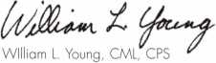

President



Vernon Kelley, CPL

I began my career in the locksmith industry in 1989 by answering a two-line advertisement in a local newspaper that simply said "Locksmith wanted. Will train." Since that time, I've worked extensively as both a commercial and an institutional locksmith. Currently, I am employed by The College of New Jersey as the supervisor of the Office of Access Control Services, and have been an employee of the State of New Jersey since 1995.

In 1992, I was fortunate enough to be awarded an education scholarship to the ALOA Convention which was held in Baltimore that year. I've been a member of ALOA since 1992 as well. In 1994, I earned my CRL. I earned my CPL in 2000.

Since 1999, I've been very active in the Institutional Locksmiths'

Association on both the local and national levels. At the chapter level, I cur­rently serve as a director but I've also worked as newsletter editor and corre­sponding secretary. At the national level I currently serve as editor of the I LA newsletter Key Issues. Additionally, I serve on the by-laws and Institutional Locksmith Certification Program committees. In the past, I've worked on the membership and conference committees.

As an author, I've been published in The National Locksmith, The Institutional Locksmith (including the premier issue), and Keynotes magazines.

I was the principal editor of the ILA "Study Guide of the Institutional Locksmith Certification Program."

If elected, I trust that my vastly differing experiences as both a commercial and an institutional locksmith can provide a fresh perspective on matters fac­ing ALOA. I would work to get a permanent institutional locksmith director position created on the Board to represent the unique issues facing those who work in-house. In addition, I would like to see the PRP more aggressively advertised to other groups in the industry as well as the general public.

I sincerely appreciate your consideration of my nomination for the office of Northeast Director.

**FOR THE OFFICE OF NORTHWEST REGION DIRECTOR**

VOTE FOR ONE (1) ONLY

(Eligible to vote: Active, Apprentice, Retired, and Life members whose business address is in Alaska, Idaho, Montana,  
Oregon, Washington, Wyoming, APO San Francisco):

Jim Jeffries, CPS

My name is James L (Jim) Jeffries, and I am running for the position of  
Northwest Director for ALOA. I have been working in the security industry  
since 1978 and have worked for others as well as myself. My former shop  
was "Jim's Safe & Vault" and in 1999 I joined forces with two others in the  
Pacific Northwest and formed NorthWest Safe & Vault Services, Inc. I current-  
ly am president of NorthWest Safe & Vault Services, Inc.

I am a member of ALOA membership # 25947, SAVTA membership #

5392, Columbia Basin Locksmiths Association and the Northwest Locksmiths  
Association.

I am running for the Northwest Director of ALOA position because I am  
not satisfied with the way the legislative action has been going in the past  
and I would like to see changes happen that benefit us as a whole rather  
than another part of the security industry, namely the alarm industry. Too many  
times the alarm industry has been able to push through portions of a locksmith  
bill that benefits them and leaves the locksmith out in the cold.

We can make changes happen if we go about it the right way. I think this  
can be done with a lot of hard work and help from my fellow ALOA members  
because we are in this together and I would like to see all of us come out  
ahead instead of behind as we usually do. I know I can make a difference  
by being Northwest Director, so I am now running for that position to try to  
make these changes and therefore make a big difference in this industry.

ALOA has made some great steps toward making the locksmith industry  
better in the past few years, but I feel that we (ALOA) can make even greater  
steps toward making the locksmith industry better for all involved in it, so I am  
running for this position to try to make this happen and therefore benefit all of  
us in the locksmith industry.

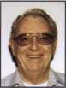

**FOR THE OFFICE OF EUROPEAN REGION DIRECTOR**

(Eligible to vote: Active, Apprentice, Retired, and Life members who's business address is in Aregentina, Austria,

Bahamas, Barbados, Belgium, Bermuda, Brazil, Bulgaria, Canada, Chile, Colombia, Costa Rica, Denmark, Ecuador, Egypt, El Salvador, England, Estonia, Finland, France, Germany, Great Britain, Guatemala, Holland, Iceland, Ireland, Israel, Italy, Jordan, Kenya, Latvia, Macedonia, Mexico, Morocco, Netherlands, Northern Ireland, Norway, Panama, Peru, Romania, Russia, Saudi Arabia, Scotland, South Africa, Spain, Sweden, Switzerland, Trinidad, Turkey, United Kingdom, Uruguay, Virgin Islands, West Indies, Yugoslavia):



Hans Mejlshede, CML

Hans has been an active member of ALOA since 1974, attending the ALOA conventions, and an ALOA instructor for more than 20 years. For many years, he was the ALOA co-chairman of international affairs. He has been honored with The Lee Rognon Award (1984), the ALOA President's Award (1986), and the GPLA Award (1987)

Currently, Hans is President of the Danish Locksmith Association. For eight years he was the President of The European Locksmith Federation and is now the honorary president of the same association. He has a Master's Degree in Mechanical Engineering from the University of Copenhagen. He is from a locksmithing family and has been a locksmith all his life. For many years,

Hans successfully pushed for ALOA to have an International Director because more than 10% of the membership lives outside of the United States. For the past four years, he has been appointed to the Board of ALOA. He would like to create a Shop Certification Program for the ALOA membership and will continue to work on a membership drive in Europe to expose more European locksmiths to the many ALOA education programs.

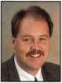

Michael Elsberry

I would like to outline what objectives I have for being a on the board of

directors representing the Northwest region of ALOA:

* First and foremost is to increase the amount of ALOA members within the Northwest Region. Currently we have approximately 309 registered ALOA members in the Northwest Territory. There are 554 locksmith firms recorded in the Yellow Pages, not counting any employees of those firms who are serious about their trade. I think our message, as an organiza­tion, is highly diminished if the President of the association does not have the forum to communicate that message.
* In that same vein, I would like to see a differentiating level between SUPERVISING locksmiths (CRL, CPL and CML) vs. Journeymen locksmiths that work for a locksmith firm/facility. I think that a SUPERVISING lock­smith should be more aware of licensing, safety, building and life safety codes. In essence, each company should have at least one person who is familiar with licensing, safety, building and life safety codes required nationally and within their state. This would potentially open the door to allowing employee or journeymen level (perhaps lower costs) ratings and memberships to ALOA.
* Education. I think education is one of the greatest items that makes our profession, proficient and professional to the public. While I am an advocate of our national conference, I think greater effort ought to be made to being additional ACE certified training to the local markets/asso­ciations at least once per year.
* Finally, I think we must continue to communicate and work with local lock­smiths on how to fight and work within existing licensing requirements to get locksmiths back on par installing gear that they are qualified to work on, however, in many cases lack the proper licensing to perform the work.

I seek your support and vote to make these ideas a reality. Please cast

you're your vote for Michael Elsberry on the upcoming board ballot.

The undersigned, being an Associated Locksmiths of America, Inc. (ALOA) member, hereby appoints Paul Kanitra and Mary May the proxies and true and lawful attorneys of the undersigned to attend the Meeting of the Membership of ALOA to be held at 3003 Live Oak Street, Dallas, Texas 75204 on June 1 1, 2004 at 10 a.m. or any adjournment thereof, and to vote on behalf of said ALOA Member as designated below:

**FOR THE OFFICE OF SECRETARY**

VOTE FOR ONE (1) ONLY

(Eligible to vote: Active, Apprentice, Retired, Life and Associate members):

□ John Soderland, CML, CMST

**FOR THE OFFICE OF SOUTH CENTRAL REGION DIRECTOR**

VOTE FOR ONE (1) ONLY

(Eligible to vote: Active, Apprentice, Retired, Life and Associate members whose business address is in Arkansas, Kansas, Louisiana, Missouri, Oklahoma, Texas):

□ C.D. Lipscomb, CML, CPS

This proxy must be signed and dated with member number to be considered valid. It must be received no later than June 9, 2004 and be mailed/faxed only to:

**Associated Locksmiths of America Attn: Paul Kanitra**

**3003 Live Oak Street • Dallas, Texas 75204 Fax: 214-827-1810**

**FOR THE OFFICE OF NORTHEAST REGION DIRECTOR**

VOTE FOR THREE (3) ONLY

(Eligible to vote: Active, Apprentice, Retired, Life and Associate members who's business address is in Connecticut, Delaware, District of Columbia, Kentucky, Maine, Maryland, Massachusetts, New Hampshire, New Jersey, New York, Ohio, Pennsylvania, Rhode Island, Vermont, Virginia, West Virginia, APO New York):

* Robert "Bob" Mock
* Vernon Kelley, CPL
* Peter Sarailian, CRL

**FOR THE OFFICE OF NORTHWEST REGION DIRECTOR**

VOTE FOR ONE (1) ONLY

(Eligible to vote: Active, Apprentice, Retired, Life and Associate members who's business address is in Alaska, Idaho, Montana, Oregon, Washington, Wyoming, APO San Francisco):

* Jim Jeffries, CPS
* Michael Elsberry, CRL

**FOR THE OFFICE OF EUROPEAN DIRECTOR**

VOTE FOR ONE (1) ONLY

(Eligible to vote: Active, Apprentice, Retired, and Life members who's business address is in Aregentina, Austria, Bahamas, Barbados, Belgium, Bermuda, Brazil, Bulgaria, Canada, Chile, Colombia, Costa Rica, Denmark, Ecuado, Egypt, El Salvador, England, Estonia, Finland, France, Germany, Great Britain, Guatemala, Holland, Iceland, Ireland, Israel, Italy, Jordan, Kenya, Latvia, Macedonia, Mexico, Morocco, Netherlands, Northern Ireland, Norway, Panama, Peru, Romania, Russia, Saudi Arabia, Scotland, South Africa, Spain, Sweden, Switzerland, Trinidad, Turkey, United Kingdom, Uruguay,

Virgin Islands, West Indies, Yugoslavia):

* Hans Mejlshede, CML

**PROPOSED BYLAWS CHANGES**

* forO against Proposed Bylaws Change #1
* for □ against Proposed Bylaws Change #2
* for □ against Proposed Bylaws Change #3

Print/Type name of ALOA Member

Member Number

Member Signature

Date

A“SAFE” _

yet“EXPLOSIVE” Experience

by Claire Cohen, CML

**2**

Keynotes • May 2004

Explosive

A substance or mixture of substances that is capable, by chemical reaction, of pro-  
ducing gas at such a temperature, pressure and rate as to be capable of causing dam-  
age to the surroundings.

Safe

A container designed to provide either burglary resistance or fire resistance of its  
contents. The type of safe selected depends on the value of the items to be protect-  
ed and the other burglary protection measures in place.

What do you find when you mix safe and vault technicians with bomb technicians?  
Meet Dave Fullarton, CPL, CPS. Dave is a full-time professional locksmith who  
works exclusively on safes and vaults. In his “spare time,” he is President of the  
Maryland Locksmith Association and an instructor at the SAFETECH convention.  
Throughout his career, he has met and networked with others who specialize in safe  
work. He has also worked with professionals in the demolition field.

“Both disciplines are highly technical,” Dave said. “Those working on safes exclu-  
sively and demolition specialists are few and far between. There are parallels  
between the two disciplines.”

We’ve all seen movies and television shows where safes are opened using explosives  
— the contents never damaged, and the perpetrator never receives a scratch or  
even gets dusty! Safe doors are blown clear of any innocent bystanders, only to  
reveal the contents—piles of money and jewels. Ah, the magic of Hollywood!

At one time, there were real ‘safecrackers,’ whose criminal specialty was using nitro-  
glycerine extracted from dynamite to blow open safes. The nitro was introduced  
between the safe door and body (known as a ‘jamb shot’) to spread the jamb wide  
enough to clear the door bolts. But the days of using nitroglycerine to open safes  
are long gone. Modern dynamite uses trinitrotoluene (TNT) as its explosive ingredi-  
ent, thereby depriving the “yegg” (old term for criminal safecracker) of his source of  
nitro. Additionally, commercial and military-grade explosives are not only strictly  
regulated; they are also expensive - probably cost-prohibitive for most criminal  
endeavors. So consequently, few burglars “blow open” safes anymore due to the dif-  
ficulty in obtaining suitable explosives and the obvious dangers to themselves.

Although fairly uncommon, the occasional attempted safe blowing does occur. They are  
attempts committed by untrained individuals, using improper materials or techniques.

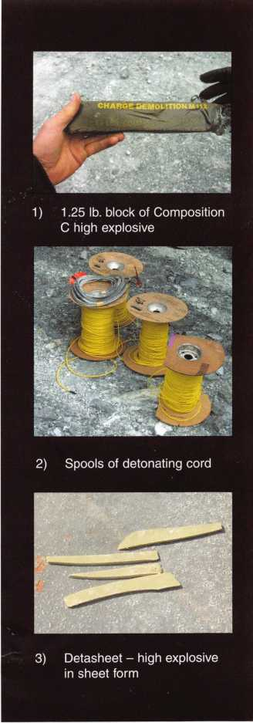

usually unsuccessful, amateurish

While on safe opening jobs, Dave and his fellow safe techs often hear the typical attempts at humor by their customers regarding the use of dynamite, C4, or other explosives to get their container open. One day, Dave realized that most safe techs have NEVER used explosives on a safe, and probably never will.

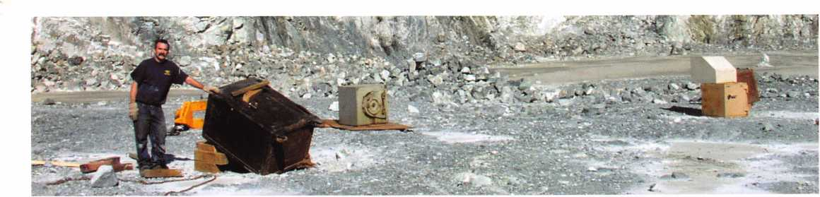

4) Getting ready-rigging safe to blow in the quarry

Keynotes • May 2004

10) Molding C-4 plastic explo-  
sive for shaped charges

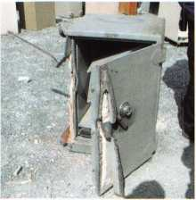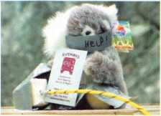

7) Hostage was last seen atop doomed GSA file.

5) Class 3 GSA file rigged to blow with Det cord, linear shaped charges and oil perforator

6) HHM fire safe suc­cessfully breached using Demex and lin­ear shaped charge

“I knew the right people to help pull this off,” he said, “and when I approached the lead bomb tech, he was more excited than I was!”

In conjunction with other professionals in the safe and vault field, Dave and his associates wanted to increase their knowledge of meth­ods and types of explosives that have been used (or could be used) to open safes.

“Whatever works and doesn’t work, law enforcement personnel can cut way down on research time during investigations if there is some knowledge of the effects of different compounds on various containers,” Dave explained. “This is pretty much uncharted territory.”

Along with input from other safe techs from across the country, the idea of getting safe specialists and explosives specialists together for a training seminar to learn more about the effects of using explosives to enter safes was born. The planning for this took about a year. As could be well imagined, the logistics were a formidable task. The group wanted every­thing to be done correctly. As well as selec­tion of suitable location, transportation of safes, security and safety issues, there were legal and regulatory obstacles to overcome.

One of the purposes of this seminar was to use some of the findings for investigative pur­poses. When safes are breeched, professionals need to understand how they were breeched. When explosives are used to attack a safe, it is difficult to determine the type of attack without proper verse. Another goal was to ascertain the feasibility of fast and efficient means of entering a security container. Case in point: Safes containing suspected intelli­gence documents and other items are being recovered in remote locations in Iraq. Without a viable and controllable field­breeching procedure, the contents risk dam­age or destruction when explosive breeching is attempted. The only other alternative is to ship these hundreds of containers somewhere to be opened, and in the meantime, keeping them secured and tracking each specific con­tainer until they can be opened. Intelligence is time-sensitive; the longer it takes to get these containers opened, the less valuable the information is. Not to mention, the logistics involved in moving, storing and securing these containers is a nightmare - and in many cases, only to find that they are empty!

A joint Safe Tech/EOD alliance from around the United States was formed. The group included military personnel as well as law

There is much more study to be done

in this field, to the benefit of both safe

and bomb techs alike.

**14**

Keynotes • May 2004

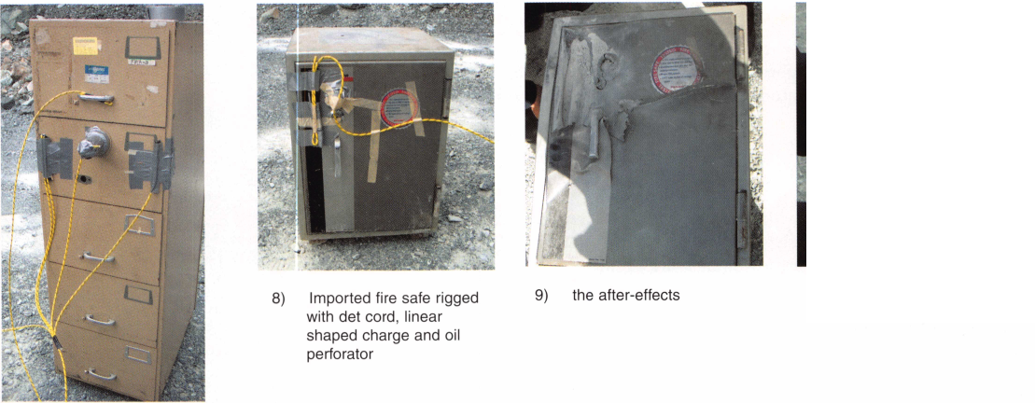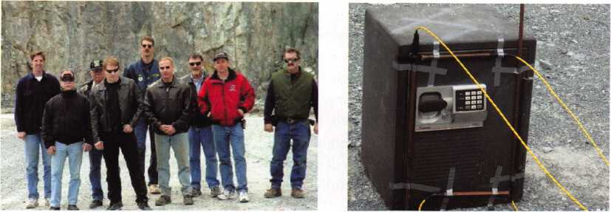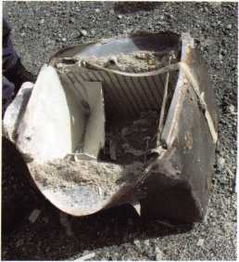

11) from left to right: Neil Stratton, Dave Wells, Bob Stabley, Mark Swetland, Ron Jewell, Kenny Hiemstra, Ken Dunckel, Dave LaBarge, Dave Fullarton

12) Sentry electronic safe rigged with four 13) The aftermath...don’t

linear shaped charges...yeah I’d say think the contents would

overkill!!! have survived.

enforcement professionals, fire and rescue personnel, and EOD (Explosive Ordinance Disposal, or bomb squad) teams.

The day-long exercise was held in the autumn of 2003 in a quarry in a rural part of Maryland. Professionals from “both sides of the fence” were assem­bled. Safety for all participating was of paramount concern. A fully-staffed fire truck and ambulance were pres­ent during the entire day in the unlikely event anything would have go wrong.

Many different types of safes were tested. A variety of safes from cheap fire safes, low-grade plate safes to higher grade safes (including lug door safes and even a cannonball) were part of the day’s schedule.

Some of the safes were easily breeched using simple charges. Cannonball and lug door safes held up well during the explosive testing. From a practicality standpoint, the use of explosives is not a particularly viable method of entry. Apart from the high cost and the overall difficul­ty in obtaining them, blowing open heavily armored, well-made safes and vaults would require large amounts of explosives, as well as a degree of

knowledge in their use and some knowledge of safe construction.

Using explosives for entry could cause a severe amount of collateral damage, harming or obliterating contents, as well as serious injury or death to the perpetrators (or innocent bystanders). The blast would certainly be heard for miles around, dramatically increasing the probability of capture. Explosives will not stop at the door of a safe. Explosives can damage or destroy the safe’s contents. After all, an explosive is a massive dose of air compressed in a specific direction. The pressure wave and associated heat will not simply stop after spread­ing the safe body or penetrating the door or wall.

Last year’s event was the first of its kind. Everybody learned something. “Each group just sort of fed off the other’s knowledge, “Dave said. ‘And the EOD personnel were totally pro­fessional and efficient.” Plans are already underway for this year’s explosive extravaganza. Safeblast ’04 will surely outdo last year’s event. There is much more study to be done in this field, to the benefit of both safe and bomb techs alike. Besides, as Dave pointed out, “Blowing safe is LOTS of fun!”

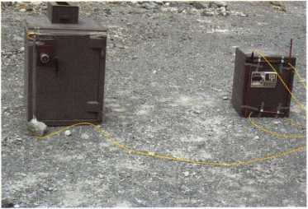

1. Sentry and US Security depository rigged to blow simultaneously

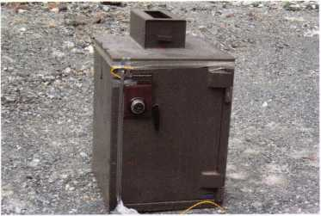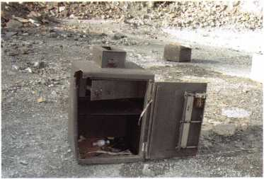

1. US Security depository rigged with det cord, linear shaped charge and demex, a high explosive in caulk form
2. Best shot of the day.. .frame spread and we could watch the door swinging through binoculars. No overkill or major collateral damage...contents would have survived.

Keynotes • May 2004

Any of you who

open safes will relate  
to this article. It started

with a simple request from

the customer: Could I open

two safes, a Schwab and a York

found in their warehouse? The com-  
binations were long forgotten and they

wanted to dispose of the safes. Before dis-

posal, they wanted them open to verify the

safes were indeed empty According to the cus-  
tomer, the safes were old, and as usual, they wanted

to know if the safes could be opened with explosives.  
Next question is how much? They didn’t want the  
safes repaired, only opened. I gave them a fixed price  
on the Schwab fire safe and a range on the York. The  
Schwab was either going to dial open quickly or I’d  
have to put a hole through the side to scope the  
change key hole. For me, the York would be the inter-  
esting safe to open. This would be my first York. I  
could get a great wheel count, but no contact feel.  
Since this is a gravity drop lever, I chalked it up to a  
very light contact.

I found this safe in TNEs Guide to Safe Opening Volume 4 by Dave McOmie (page 196, and similar safes are on the next couple pages). Dave has provid­ed a wealth of information on safes in his books, and this York was no exception. According to Dave, the lock was a Sargent & Greenleaf model 6826 with a gravity drop fence. Dave suggests using a great scope hole, which can be drilled outside the dial ring around 67 to 69. I used his dimensions and entered the lock case in an open area away from the wheel pack. This is a good hole, but not a great hole, at least not with my Hawkeye scope. I could view three of the four wheels. Unfortunately, the wheel I could not see was

the first wheel. The reason for not seeing the first wheel is the shroud on the lock curb. The Hawkeye scope uses a mirror at the end of a tube at a 90- degree angle. This allows for a straight view scope to see at an angle. I’m not certain better optics would have helped, but they couldn’t hurt. At first, I thought the lock might only be a three-wheel lock, but wheel count was definitely four wheels, so I started looking more carefully. All I could see on the first wheel was a slight edge. The gate would show up as a change in the shadow. Once I found the numbers, I transferred it to the area of the fence, about 15 to 20 numbers lower. I tried all the combinations in this area and no luck. After several more attempts at transferring the wheel pack around and getting nowhere, I debated the next step. I decided to angle drill at 7 or 8. This would put me in an open area (I hoped) above the wheel pack with a view of the lever/fence.

Once into this area with a quarter-inch hole, I enlarged it to 5/16 inches to give allow a little move­ment with the scope. The wheel pack curb shroud is cut away on top. I now had a good view of all 4 wheels and the fence; the lever was not quite in view.

I dialed the combination parking all four gates under the fence and turned back to the right to open. As I dialed, I checked the numbers. Sure enough, this was one of the combinations I used during transferring.

As the drive cam gate came under the fence, it didn’t drop! No wonder my transferring didn’t work! This also explained the lack of contacts. Leaving the drive cam gate under the fence I started beating on the face of the door with a deadblow hammer to see if the lever/fence might drop. I tried some hammering dur­ing the transferring exercise, but not being able to see the lever/fence movement meant I wasn’t certain of the exact location to place the wheels. Finally, the



Why Oh Why Won’t You Open?

By Greg Perry, CML, CPS

**6**

Keynotes • May 2004

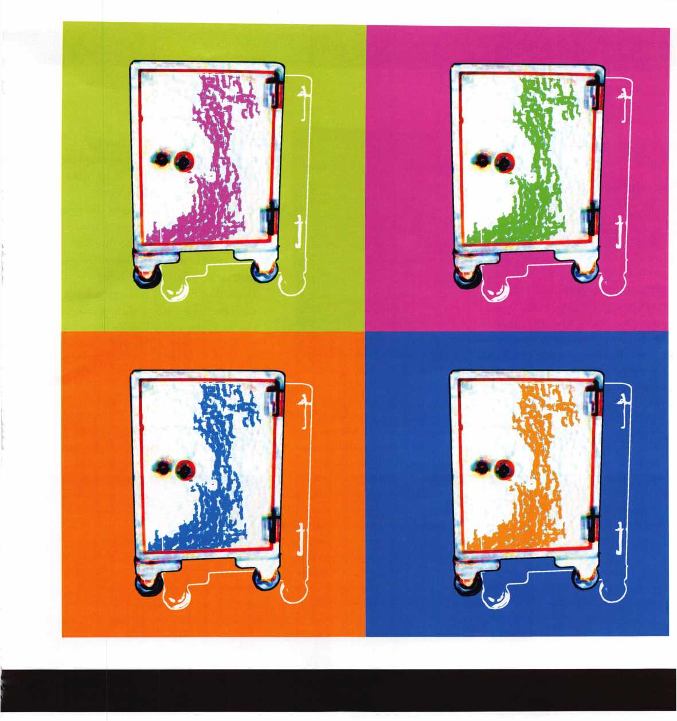

I started

beating

on the face of the door with a

deadblow hammer

Keynotes • May 2004

lever/fence dropped and the safe  
handle would turn.

Once the outside door swung  
open, we found an inner door  
with a spring-latch lever lock.

The customer asked if I could  
open it quickly, so out came the  
hammer and punch. In hind-  
sight, I think a better option  
would be to drill for the bolt  
and push it back. The lock case  
was cast iron, making driving it  
in difficult. Swinging the inside  
door revealed a beautiful interi-  
or including a jeweler's chest in

the lower portion. Seeing the dial taped, I turned the  
handle to find it was open. Thank goodness, I had my  
fill of challenges for the day.

Now it was time for pictures and  
dimensions. As usual, the complete  
dimensions are being sent to Mike  
Oehlert at the Safe and Vault  
Technicians Association in the form  
of two technical bulletins. I started  
with the inner door. The interior  
jeweler’s chest uses an interesting  
lock. It’s an S&G roller bolt.

Instead of the bolt retracting flush  
with the lock case or sliding into  
the lock, the roller bolt in the  
locked position is almost flush with  
the lock case. Instead of retracting  
the bolt, it rolls or pivots up in the

lock case, allowing the safe boltwork to enter the lock  
case. Once again, I checked Dave’s book for identifi-  
cation. He lists this lock as an S&G 6561. Although I  
didn’t need to drill this door, I looked for a location,

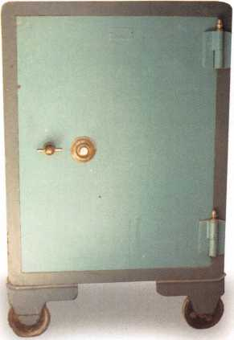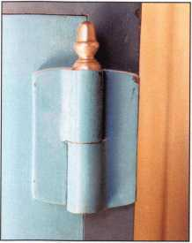

...I had

of challenges

my Fill

today.

**8**

Keynotes • May 2004

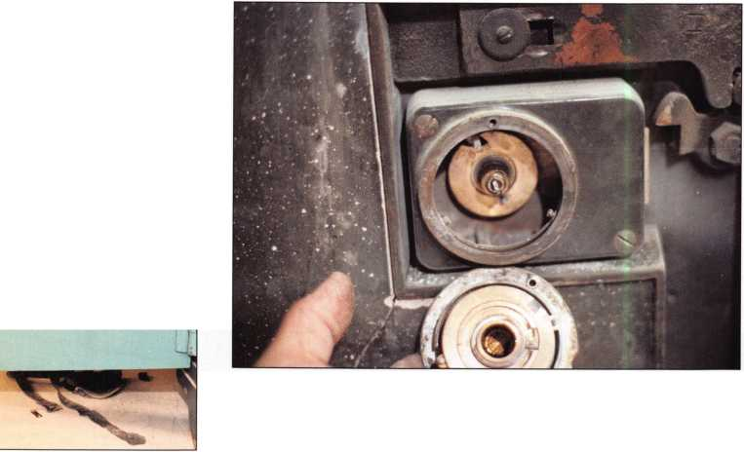

the fence drop into the gates is frustrating. Not being able to see why or knowing the exact location to transfer to is even more frustrating. If I needed to drill another York,

I would drill outside the dial ring at 67, around 2 3/8 inches out, provided I felt contact points. Next, I’d transfer the combination to around 96. If I felt daring, I might angle drill again, especially if I did­n’t feel contact points. Why not drill at drop in? This is a front-mounted cam, mean­ing you can’t see the wheel pack because the lever is in the way

There are times I feel frus­trated and question my own abilities. I begin to wonder, “Why oh why won’t you open?!” Then I get past the problem and the door swings. The frustration is gone and elation kicks in. It is such a rush. Now I’m ready for my next frustrating opening!

because the next time I come across this door, I might not be so lucky. This lock uses an indirect drive or gear assem­bly to move the wheel pack. The fence is located 1 w inch­es over and 1 inch up. A bet­ter location is to drill 2 w inches over and 1 1/8 inches up. This is a great location to sight the wheel pack under the fence.

Each time I run into a safe that won’t open using some­one else’s (or even my own) method and it doesn’t work,

I look at why. I also want to determine a better way if possible, or at a minimum, determine where I went wrong. I prefer to be able to see the lever/fence assembly. The times I’ve had the most difficulty are when I can’t see movement of the lever/fence. I like to find locations that give me a view to see how the parts are interacting. Transferring and not having

Keynotes • May 2004

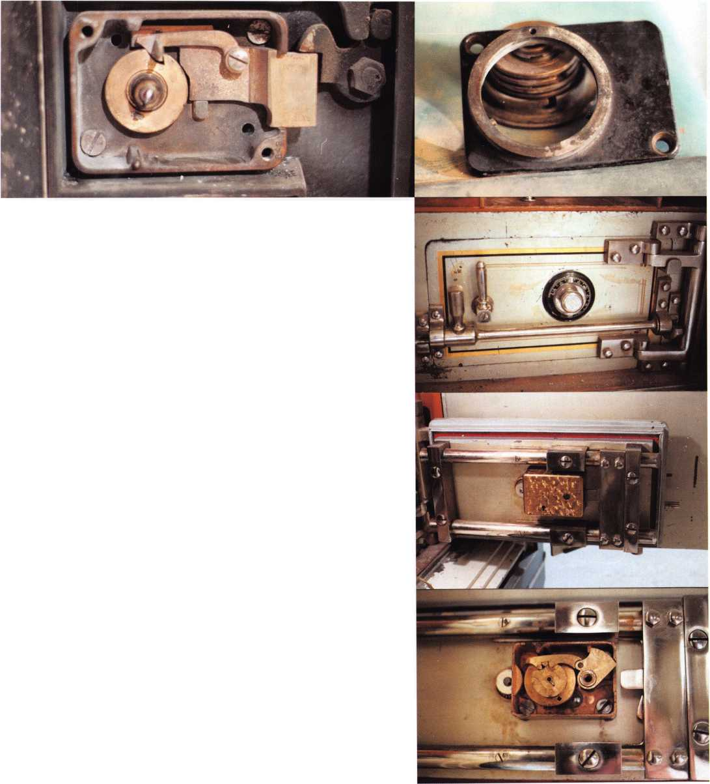

***V***

I recently had the  
opportunity to select

the electronic lock a cus-

tomer wanted installed on  
his gun safe. I’ve used and

installed several different elec-  
tronic safe locks, but I’ve always

been a bit shy about using them since  
they are generally not as reliable as

mechanical locks. Over the last year, I’ve been

watching the posts on the SAVTA web site  
([www.savta.org](http://www.savta.org)) about GlobaLok’s XLN. No one  
has reported a lock failure! I’ve spoken with several  
other safe technicians who use the XLN, and they  
sing its praises. Now it’s my turn to try one. I called  
Bob Stabley at LA Safe & Vault to send me a lock.  
This install was a little more challenging, since he for-  
got to send the instruction sheet. I called Bob, who  
was loading safes for the SAVTA convention and he  
walked me through the install.

The safe it’s going on is a Sun Welding Scout gun safe we sold many years ago. The first order of business was to remove the old lock. It can be seen in photo i. Next up in photo 2 is a view of the lock, keypad and parts (as it came out of the box). The cable is double- ended, meaning it plugs onto both the lock and the keypad. First, the spindle is attached with the enclosed roll pin to the inner dial knob. Next, the dial ring is attached to the outside of the safe. The inner hub is installed to the dial ring, extending the spindle into the safe (as seen in photo 3). The spindle is meas­ured to leave about 7/8-inch sticking out of the safe door, into the lock body. Next, the tube needed to be cut to size. Bob recommended about a half inch longer then the door thickness. The dial ring is then removed, and the cable is plugged. Next question is,

which connector on the dial ring does the cable plug into? It turns out that the manufacturer provided two different locations to accommodate different lock mountings. The next step before installing the dial ring is, as Bob mentioned at least three times, is to remember to plug the battery cable into the connec­tor on the dial ring. The lock is shipped with the cable unplugged to prevent battery drain. It’s also tucked in behind the keypad, so at first glance, it looks plugged in already.

Going back, the safe tubes are installed in the spindle hole and the cable is fed through the outer tube.

Next, the dial ring is attached with the enclosed screws. At this point, I ran into a slight problem. The Allen screws are about 1/16 inch too long, and they are hardened. I tried grinding them down, but the threads were damaged. Looking around my truck, I found a box of screws I have for attaching the StrongArm MiniRig template plates to the safe. Perfect length for attaching the dial ring. Next, before tightening the screws, be sure to align the dial ring with the spindle hole (as seen in photo 4) for smooth operation. Install the inner knob with the spindle, and route the cable from the dial ring to follow the lock body cutout. In this case, the cable is routed up and the lock body is installed with the four mounting screws. The next step in installation is to attach the relock plate. The lock is drilled for screws in the same locations as the back cover screws for the S&G 6741, which was removed. I’m not sure why the holes were not tapped. It meant a trip back out to the truck for a bottom or plug tap, but I didn’t complain loudly since some locks use different screw locations, requiring drilling new holes. Last, the cable needed to be installed into the lock. If the lock or keypad needs to be changed, there is a procedure for calibrating the



XLN and the Gun Safe

By Greg Perry, CML, CPS

Keynotes • May 2004

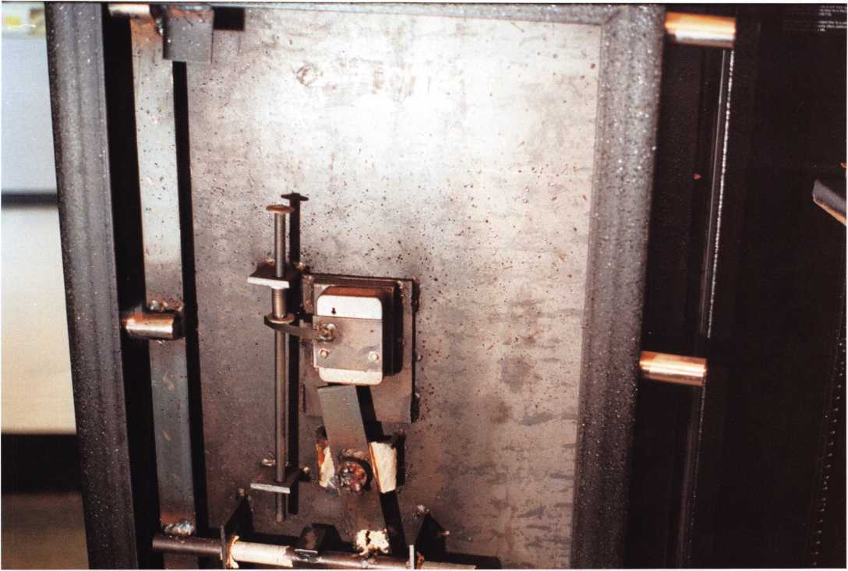

lock body and keypad; otherwise, the factory has already calibrated the two parts for you.

The final step of the installation is to program new numbers into the lock. The original combination is 123456; however, this number will not open the lock. It is to be used to program the lock the first time. 123456 is the only number that cannot be used as a combination. Programming is so simple the instruc­

tions are printed on the lower half of the dial knob. Start by pushing the PROG button then 1 and the current master code. Next enter the new 6-digit mas­ter code twice. To open the lock, enter 1 and the 6- digit code. Next, when the green light comes on, turn the inner knob to retract the bolt. User 1 is the mas­ter code. If another code was needed, then the user would be user number 2.



Over the last year, I’ve been watching the posts on the SAVTA web site ([www.savta.org](http://www.savta.org)) about GlobaLok’s XLN.

No one has reported a lock failure!

Keynotes • May 2004

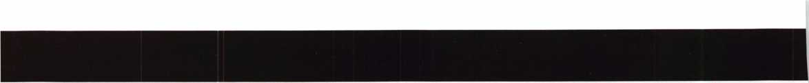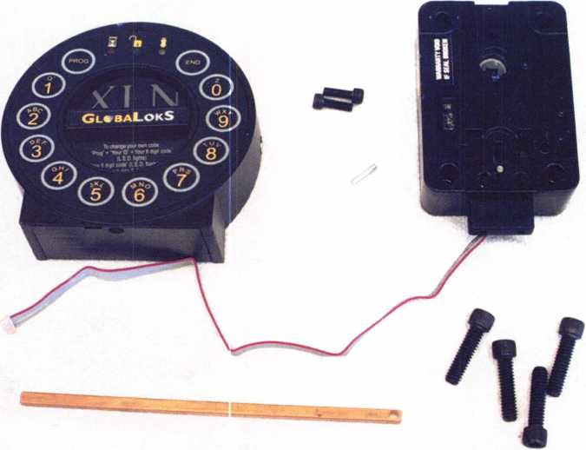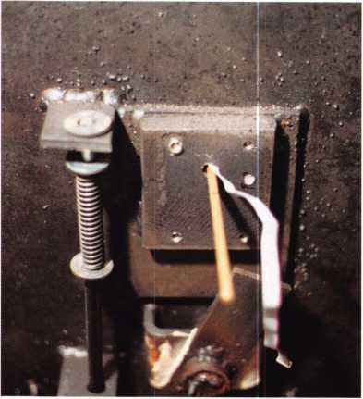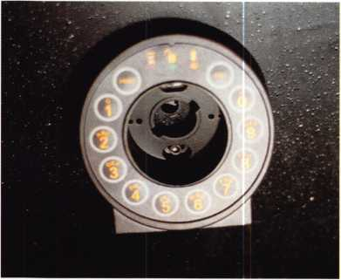

The lock offers some interesting features, such as duress code, low battery fail (with your choice of the lock failing open or locked), time delay and many other features. I found the ability to reprogram the lock with the door closed a little scarier. In fact, my customer called the next morning thinking he might have reprogrammed the lock and wanting help. It turned out he simply had put himself into the io-minute lockout mode after entering the combi­nation wrong three times.

No safe article would be complete without at least a quick look inside the lock. Photos 7 and 8 are that quick look. Ignoring the warning about the warranty being voided by my cutting the label on the side of the lock, I found a screw under it holding the lock body together. I looked around for the vulnerable points in the lock case, should I need to open one. Fve heard of a spindle hole opening technique using the SpikeMaster tool, and Bob also has a drilling template available. Since this was a new lock, I did­n’t want to snoop too much. I did find the circuit board has a switch requiring a probe to move the actuator out of the way before the card would seat.

Keynotes • May 2004

Established 1986

Safe & Vau/f

Technicians Assoc.

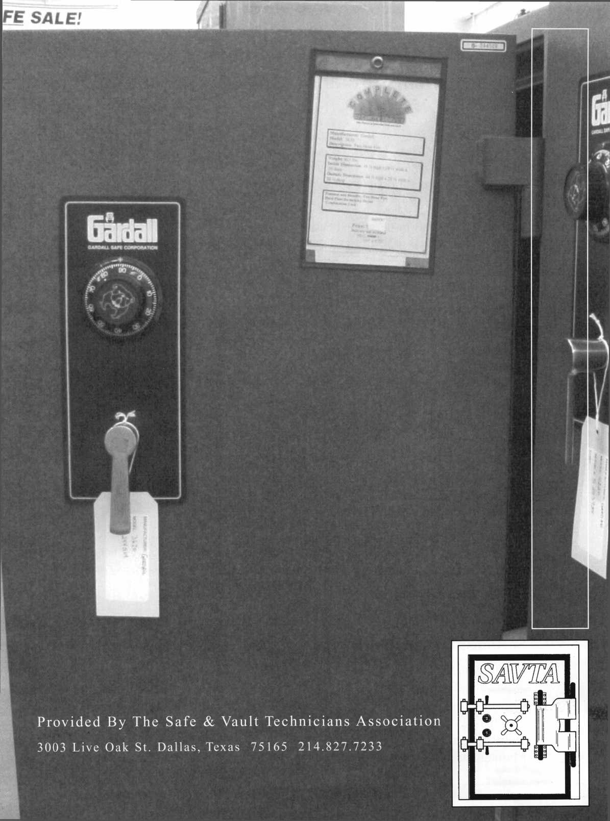

Buy with confidence

from your local safe and vault service company

Buying a safe to protect your belongings is a good investment, if you buy the right one that is. Despite what you might see for quick purchase in many of the large discount stores, buying a new safe should be a well thought out decision and not just an impulse purchase. A safe is a specialty item and is always best purchased from a reputable dealer who can work with you and answer all ofyour important questions on construction, ratings, and levels of protection.

Each year, thousands of homes and businesses are burglarized. No one is exempt from crime, regardless of where you live and work. Thieves are largely interested in items that are small enough to carry out of the home, such as jewelry, guns, cash, check books, credit cards, tools, spare keys and more. Many of these items can be sold to pawn shops and they are also “quick sale” items out on the streets.

Do you have a safe in your home or place of business? If not, now might be an ideal time to think about getting one. All of the items mentioned earlier can be locked away in a safe, thereby stopping personal loss.

This booklet is provided as a public service by the Safe & Vault Technicians Association and your local safe service company. In it you will find valuable infor­mation to help you in purchasing a new or used safe for your home or office. This booklet lets you see what is available and it should give answers to all of your ques­tions. Pricing is not addressed however, as it will vary from state to state and from store to store. Contact your local safe and vault company for pricing.

T

here are many manufacturers of safes, both foreign and domestic. There are  
also many manufacturers who are no longer in business, but, their products are  
still available as used equipment. In this booklet, no specific brand is men-

tioned. Instead, we will look at the types of safes that are available, how they are built  
and rated, and what they are designed to protect. When you get ready then to purchase  
a safe for your own use, you will have a firm understanding of what to look for.

Sections:

Should you buy a new or used safe? Types of safes available Construction Ratings

Delivery and installation Maintenance

Page 2

***The Consumer's Guide To Buying a Safe***

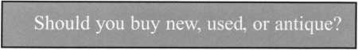

To start off, let’s look at the differences between new safes and used equipment.

We can divide all safes into 3 available categories, to give you an idea of what to look for. The categories are New, Used, and Antique.

Should you buy new, used, or antique? That depends upon your needs.

New: If you are a business that stores large sums of cash overnight you should go with a new safe or current, used equipment that is rated for theft. Many old safes do not qualify for insurance coverage in the event of a loss, and that is an important thing to consider. Likewise, the storage of large sums of cash and jew­elry, expensive guns, and important family heirlooms, should be stored in a new or used, rated container. The main reason again is for insurance coverage.

Used: There is certainly nothing wrong with the purchase of a used safe as long as you buy it from a reputable dealer that can guaranty it’s reliability. A profes­sional safe service company will take in a used safe and mechanically refurbish it to new condition. Large shops will occasionally repaint these used containers as well, to make them look good as new. As long as the safe has been worked over, it is just as reliable as a new one and it will last a lifetime. If you can stand a few scratches on the paint here and there, shopping the used market can save you a lot of money. New or used, just make sure the safe is rated for what you want to store. We will look at ratings in just a little while.

Antique: If you like the antique appeal of an old safe then you might want to consider safes that were built in the mid to late 1800’s. Some of these antique safes are quite ornate and really add character to any home or office. Valuables can surely be stored in many of the older safes as well. You might want to check with your insurance company prior to buying an antique though. You might not get a high enough coverage for what you want to store and protect. Not all used safes are antiques, but all antiques are used safes.

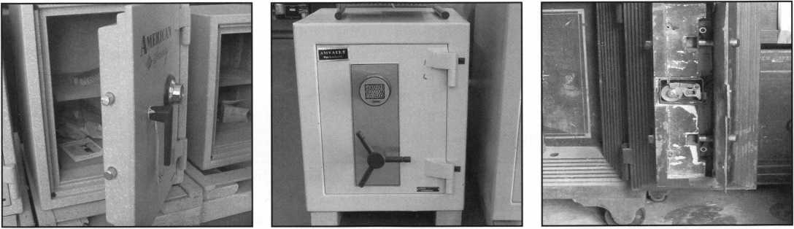

New

Used

Antique

The Consumer’s Guide To Buying a Safe

Page 3

Types of safes that are available

We can divide safes into 3 style or type categories - the floor safe, the wall safe, and the upright chest-type safe. They are found as new, used, and antique. Each has it’s advantages and disadvantages as shown.

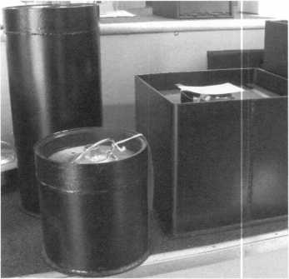

Floor safes have either round, lift- out doors, or square hinged doors. Floor safes are designed to be installed into the foundation (floor) of the home or office. It can be a concrete slab foundation or it can be a pier-beam type floor. A professional installer will need to cut a hole into the foundation to do the installation.

Advantage: A floor safe has the advantage of concealment. Once it has been installed, it is flush with the floor and then covered with a carpeted lid to match. Intruders don’t know it’s there, adding to it’s security. Floor safes are also somewhat fireproof, as it is below rising heat and surround­ed by the concrete pour of the installation. There could be water damage to contents however, so store papers in plastic containers. Disadvantage: Limited storage space for larger items and harder to access by the user. Choice of location for installation can be somewhat limited as well.

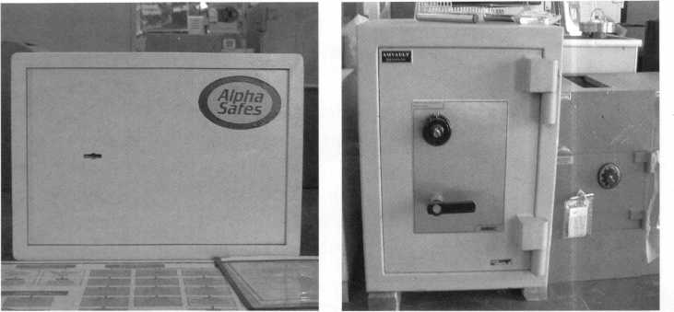

Wall safes, just like floor safes, have either round, hinged doors or square hinged doors. Wall safes are designed to be installed into a wall in between the wall studs. A professional installer will need to cut a hole into the wall to do the installation, (key locked safe shown).

Advantage: A wall safe has the advantage of concealment. Once it has been installed, it is flush with the wall and then covered with a hanging picture if so desired. Intruders don’t know it’s there, adding to it’s security. A wall safe provides easy access. Disadvantage: Limited storage space for larger items. Not as heavyweight and secure as a floor safe or an upright chest-type safe. Wall safes are not all that easy to find, as not all dealers stock them. Selection is small too.

The upright or chest-type safe is

probably the best safe to purchase. It has a large storage capacity and is easy to access. This type of safe is the most widely used and man­ufactured safe of any. It can be set up with custom-fitted interiors, is best to use for large items, can be ordered in a variety of sizes and weights to meet any need, comes in all UL ratings, and is most suit­ed as a cash-range safe. This type of safe can be purchased with cash drop slots and cash depository drawers and hoppers for commer­cial use. They are designed to sit on the floor and can also be anchored down if desired.

Advantage: Mentioned above. Disadvantage: None really, as long as floor space is available and the floor is suited to handle the weight.

All 3 style categories can be used in a residential or business environ­ment. The purchaser needs to pick the style that best fits their needs. The chest type safe is available in all UL ratings. A UL rated fire and burglary floor safe or wall safe is much harder to find in stock.

Page 4 The Consumer s Guide To Buying a Safe

Construction of safes

We can divide safes into 3 construction categories - the plate steel safe, the fire safe, and the composite built safe. They are found as new, used, and antique. Each has it’s advantages and disadvantages as shown.

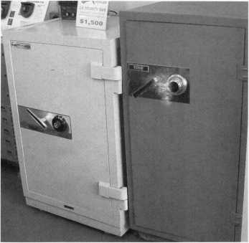

The fire safe

Fire safes are very popular, in both home and business. The fire safe is designed to protect paper and special documents from burn­ing. The Class 350 - 1 Hour and Class 350-2 Hour fire ratings are probably the two most common ratings. For the protection of media and disks, a higher rating is required. For moisture protection for stamp collections and such, a fire safe is needed that uses a dry fire clay in it’s construction. Check with your local dealer. Advantage: Good fire protection. Also lighter weight which is less stress on the floor. Most fire safes are also rated for impact protec­tion, meaning, if it were sitting on an upper floor and fell through during a fire, it would remain locked to protect the contents. Disadvantage: The standard fire safe is not rated against loss by theft. Most are on wheels as well, and can be removed from the premise much easier.

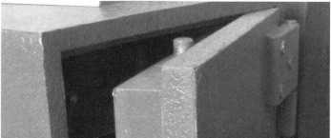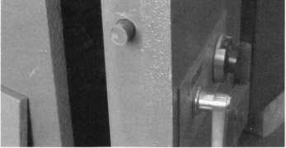

The plate steel safe body and door

The plate steel safe is just that. Built by welding solid sheets of steel together, this type of safe has been the most commonly used in the range of cash protectors. The steel plates will vary in thickness, according to the rating of the safe. Advantage: Solidly built, heavy, and has the strength of steel. Disadvantage: Can be cut by a cutting torch, although this type of burglary attack requires the use of heavy equipment not commonly used by intruders.

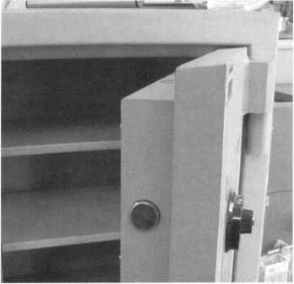

The composite built safe

The composite built safe offers both fire and theft protection. Look for affixed labels on the unit to see if it is rated for both. Many are, some are not. The thick walls of the body and door prevent fire damage and make the safe much harder to destroy in a burglary. The composite designed safe is quickly becoming the safe of choice for home and business. Advantage: Fire/theft protection. Disadvantage: None really, but purchase price could be higher.

Safes are constructed to meet specific ratings and security require­ments. For a safe to carry an Underwriters Laboratories Inc. (UL) label for instance, it must meet the basic requirements for products covered by the Standard for Safety UL 687 - Burglary Resistant Safes.

The following pages give a brief coverage of the UL 687, to help you understand what the ratings mean. Your local safe and vault service company can give you further information if you need it. Look at the ratings shown to determine what you need, for what you want to protect. The higher the rating, the better the insurance cover­age. Ask your agent about requirements.

The Consumer s Guide To Buying a Safe Page 5

A condensed guide to safe labels

Ratings

What The UL Labels Mean:

TL

Means tool resistant.

TRTL

Means torch and tool resistant.

TXTL

Means torch, explosives, and tool resistant.

X6

When X6 is part of the rating label it means that all six sides of the safe have been tested and rated. Only the door and the front face of the body are tested on the TL units without the higher X6 designation.

If a safe is a UL rated unit it will  
be marked with one of the  
following labels:

TL-15 Safe

A safe that is tested to be tool resistant for a net working time of fifteen minutes. The TL-15 safe has to weigh at least 750 lbs. or have provision for anchoring.

TL-30 Safe

A TL-30 rated container is basi­cally a TL-15 container with a bit more muscle. It must resist entry means for a net working time of thirty minutes. The TL-30 safe will qualify for a higher insurance rating if you need it.

TRTL-30 Safe

A safe that is tested to be torch and tool resistant for a net work­ing time of thirty minutes. The safe must weigh at least 750 lbs. or have provision for anchoring. The body of a safe that is rated TRTL-30 is constructed of metal encased in reinforced concrete. The metal has to be equivalent to at least one inch of solid open- hearth steel with an ultimate tensile strength of 50,000 psi. The concrete encasement has to be at least three inches thick and has to be made at the manufacturing facility.

TL-15X6 Safe

A safe that is tested to be tool resistant for a net working time of fifteen minutes, on all six sides of the container. That is to say, the door and the top, bottom, back, and two side panels of the body. The safe must weigh at least 750 lbs. or have anchoring provision.

TL-30X6 Safe

The TL-30X6 safe is basically a TL-15X6 safe but with a bit more muscle. It must resist entry means for a net working time of thirty minutes on all six sides. It carries a higher insurance rating than the TL-15X6.

The UL rating labels are gener-  
ally found on the door of the  
safe, either inside or out.

The label will be permanently  
attached by rivet or other means

***Page 6 The Consume?*** s ***Guide*** 7o guying a ***Safe*** |

TRTL-15X6 and 30X6 Safe TRTL-60X6 safe

These safes are tested for torch and tool resistance for a net working time of fifteen minutes on the TRTL-15X6, thirty minutes on the TRTL- 30X6, and sixty minutes on the TRTL-60X6. All six sides of the container are tested. Any one of these ratings have a minimum weight class of 750 lbs.

TXTL-60X6 safe

A safe that is tested to be torch, explosives and tool resistant on all six sides for a net working time of sixty minutes. A safe meeting the TXTL-60X6 rating must weigh at least 1,000 lbs.

There are light-weight plate steel safes constructed and classified as being B rate or C rate. They are as follows:

B and C Rated Containers

B rate:

Is a light-weight container having a half inch plate door and a quarter inch plate body.

C rate:

Is a light-weight container having a one inch plate door and a half inch plate body.

Ratings of safes - new and old

In General

When a safe is presented to UL for testing the manufacturer has to supply construction drawings and test samples. Using certain tools the UL test teams beat, pry, wedge, cut, grind, and drill on the test safe, trying to force the unit open, or at least create a specified opening through the safe door or the safe body.

Dials are knocked off and spindles are punched. Handles and bolt- work are punched and forced and explosives are used when called for. A container that passes the test is awarded the rating sought after, whichever that may be. Net working time is defined as actual attack time. When it’s necessary to change tools, insert new bits, cut­ting wheels, etc. the time is halted.

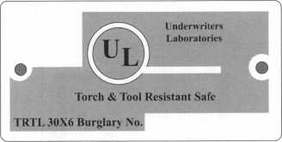

Shown above is one style of UL  
label that will be found. Other  
styles exist but they all point out  
to the consumer that the product  
is UL rated.

Not all safes are UL rated. The  
ratings are really only important  
to the consumer IF he or she  
wishes to insure contents against  
loss. Smaller value storage can be  
done in a standard B or C rate  
safe or a fire safe.

T-20 Label

The T-20 rating is an old UL designation. It means tamper  
resistant door for twenty minutes. The T-20 label was  
quite popular years back, and was typically seen on safes  
that also carried a fire resistance label.

Fire Resistance Labels

A fire classification label determines the level of  
protection a safe will provide in a fire.

Fire Resistant Safes:

Class 350 - 4 hours A label  
Class 350 - 2 hours B label  
Class 350 - 1 hours C label

An A label fire safe will maintain an interior temperature  
of less than 350 degrees F when exposed to a fire as per  
the standard time temperature curve for 4 hours at 2000  
degrees F. A B label, for 2 hours at 1850 degrees F, and a  
C label for one hour at 1700 degrees F.

Classes 125 and 150

These higher rated classes will maintain lower interior  
temperatures and humidity levels when exposed to fire,  
for the protection of computer media and diskettes.

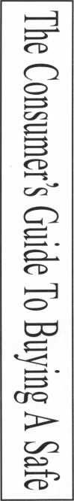

S.M.N.A. Labels

This rating system is no longer used. There are many used safes for sale that carry these labels. Listed are the 3 most common for fire safes. There are many others too - for money safes, vault doors, and other fire ratings.

S.M.N.A. stands for Safe Manufacturers National Association:

|  |  |  |  |
| --- | --- | --- | --- |
| SMNA | Type | SMNA Class | Type of Product |
| Fl-D | Fire safe | Class A | 4 hour fire resistant |
| Fl-D | Fire safe | Class B | 2 hour fire resistant |
| Fl-D | Fire safe | Class C | 1 hour fire resistant |

( Listed are just some of these old rating labels )

The Consumer s Guide To Buying a Safe Page 7

Delivery, installation, mai



Once you purchase your new safe you will need to have it delivered and setup, unless of course, it’s a small enough unit for you to take with you, or you have means to haul a larger one yourself.

Most safe service companies have delivery and setup people to do this type of work. If the safe is a small chest-type, delivery and combination setting is really all that is needed. A much larger safe however, will need to be put into position and then leveled to insure

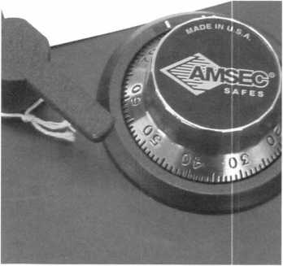

The very reliable combination lock.

proper door set. A safe door should stay at any position it is stopped at and should not “walk” or swing shut at all. Once done, a new combination can be set and the safe is ready to go.

A chosen location for a wall safe or floor safe installation will need to be properly surveyed to make sure that location is clear of any hidden water or electrical lines. This is the type of service that can be provided by a competent safe and vault service company.

Now that your choice of safe has been delivered and set up and a new combination has been set, it is pretty much maintenance free from there. If problems do occur though, make sure you contact the place of purchase right away. Don’t let small problems get pro­gressively worse until a lock-out occurs. For heavy and commercial use of the safe, a yearly service and maintenance contract is advisable. Such a service can pre­vent a lock-out from happening. Ask your safe dealer for details.

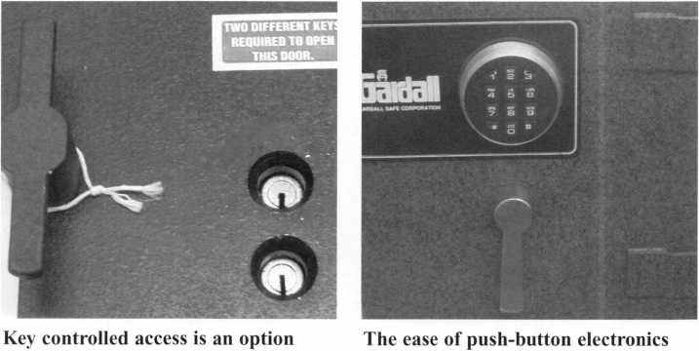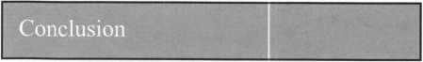

Decide on the purchase of new, used, or antique.

Select the type of safe that best fits your needs.

Choose the construction of the safe you like best.

Consider a rating to meet insurance requirements.

Set up a delivery/install date.

Buying a safe is a good investment. Working through your local safe  
and vault service company will assure you of service and support after  
the sale. It’s a good feeling to know your items of importance will still  
be there when you return home each day, and that’s the feeling you get  
when owning your own safe.

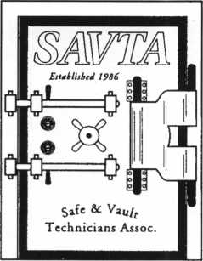

This publication is protected under  
copyright law by SAVTA. 02/12/04.  
All other parties must obtain  
written permission to copy.

Page 8 The Consumer’s Guide To Buying a Safe

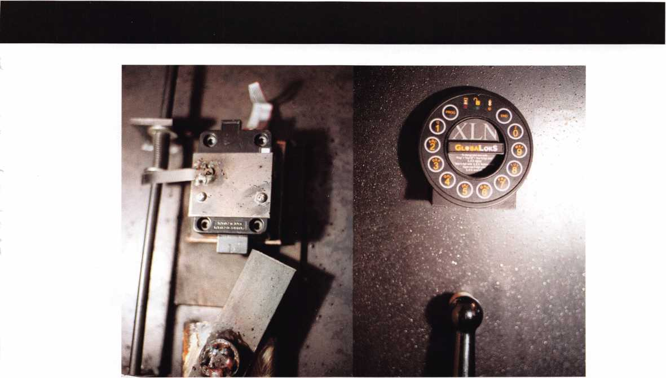

The XLN is a lock that is easy to install and looks to be quite durable. The keypad and dial ring are made of die- cast metal, so they should hold up better than many of the other plastic keypads. Pm going to be curious how the membrane keypad holds up over the years, but even if it fails, it can be replaced without destroying the lock.

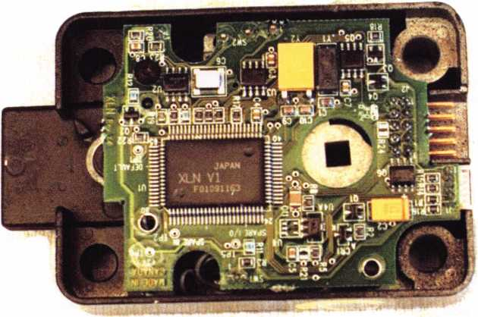

Keynotes • May 2004

The S c h I

By Dave Thielen, (ML

Keynotes • May 2004

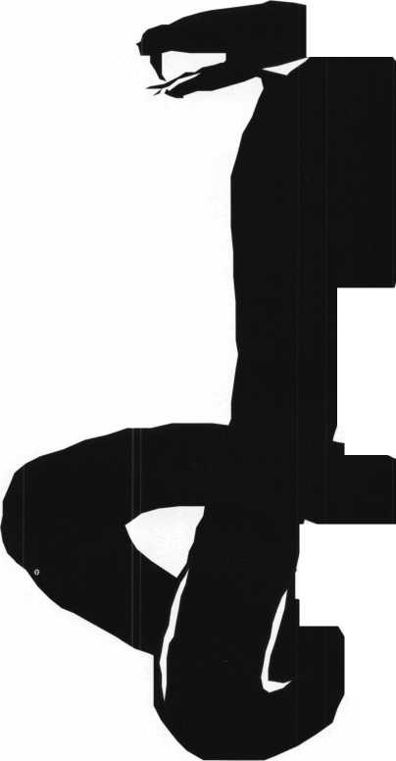

The Schlage Cobra is an 3.ttr^CtivCj battery-powered electronic lockset that is

easy to install, maintain

and program.

1

2

3

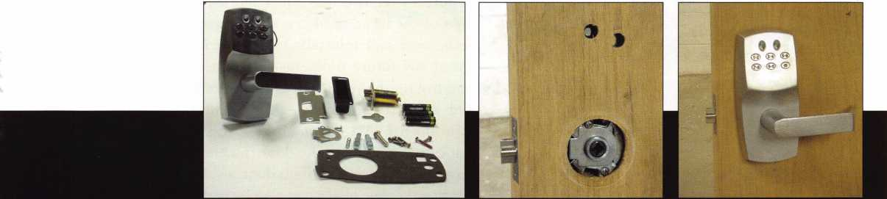

Caution: Those chilling snake eyes are watching! The Schlage Cobra is an attractive, battery-powered electronic lockset that is easy to install, maintain and program. The Cobra is available in a cylindrical or mortise lockset. We will take a closer look at the cylindrical version.

Photo i shows all the parts that come with the lock, including latch, strike, batteries, inner chassis, outer chassis, latch guard, weatherproof gasket, all mounting screws (includ­ing four tamperproof spanner screws) and screwdriver. Photo 2 shows the outside of the door with latch and latch

guard installed. The latch guard is a nice added pro­tection that goes inside the lock housing where it connects to the latch to protect against ice pick attacks.

To mount the device on the door, only two addi­tional 19/32 holes are required to be drilled through the door, provid­

ing you have a standard 161 lock prep. These two additional holes allow us to install the wiring har­ness and the mounting stud. A template is provid­ed to drill the additional holes, or you can use the gasket as a template to mark your holes.

Photo 3 is the exterior of the lockset.

Keynotes • May 2004

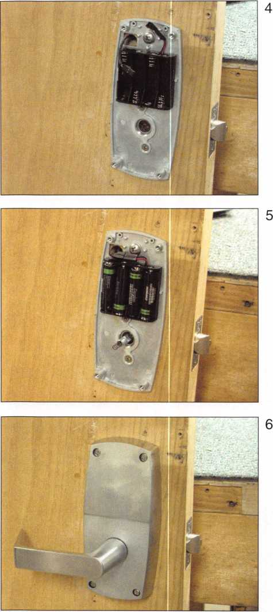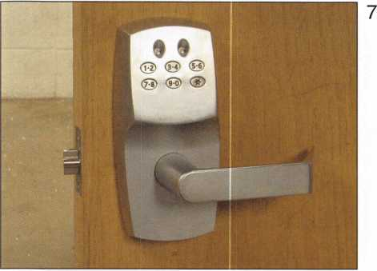

Photo 4 shows the inside chassis mounted.

Photo 5 has the batteries and spindle installed. Use four AA alkaline batteries. The batteries should provide around 80,000 lock/unlock cycles, or roughly two or three years.

Photo 6 is the complete unit installed on the inside of the door.

Photo 7 is the complete unit installed on the exterior of the door. Not visible is a gasket that sticks on to the exte­rior unit to protect from dirt, weather and moisture.

The gasket is included and should always be used.

Photo 8 shows the four tamperproof screws and screw­driver provided. I call these “snake eye” screws.

The Cobra features a clutching lever to reduce damage from acts of vandalism.

To change hand, or reverse the levers, it is a simple pro­cedure to remove one Allen screw located on the back side of the lever, dead center. Remove the screw, flip the lever over and reinstall. I recommend using Loctite to avoid any future problems. There are two lever designs and five finish options: Bright Brass 605, Satin Bronze 612, Oil Rubbed Bronze 613, Bright Chrome 625 and Satin Chrome 626. A 2 3/4 inch backset is standard; a 2 3/8 inch backset is available. The door thickness can be from 1 1/2 to 2 inches. For a 1 3/8 inch door, a shim plate is available. Optional cover plates can also be ordered to cover exist­ing lock preps.

Photo 9 is where a manual key override is installed. This is on the bottom of the lockset. I recommend removing this plug and installing a small format interchangeable core to provide an emergency mechanical override should the electronics ever fail.

When the core is removed with the control key, the lock automatically unlocks.

Photo 10 shows the plug and small pin that holds it in. To remove the plug, simply push in on it and pull the small pin out. Either the plug or core must be installed to make the unit lock.



Keynotes • May 2004

Let’s talk about the Cobra functions and program-

ming. There are up to ioo codes that can be  
programmed into the lock. All programming is  
done manually at the keypad. There are several  
functions that can be programmed to make the  
lock very versatile.

1. Normal function codes unlock the lock. When  
   the lock is unlocked, the green LED will flash  
   for a few seconds than the LED will stop  
   flashing and the lock will relock.
2. Toggle function codes will

unlock the lock indefinite-  
ly. When the toggle code  
is entered a second time  
the lock will relock, and  
the LED will flash  
once. This function  
allows you to leave the  
lock unlocked for extended

periods of time to accommodate  
different office hours, or shifts, etc.

1. Freeze/Lockout codes prevent other codes from working. If it is locked, a pass-thru code will unlock it, but all other codes will not. Another lockout code is required to reverse this situation.
2. One-use codes unlock the lock only one time. After it is used, it is deleted. This is a nice feature to be able to give a visitor, or delivery person, or repair person a one-time access.
3. Supervised codes require that two different super­vise codes be entered in order to unlock the lock. This can be used on money rooms, or other areas where two people need to be present to gain entry.
4. Pass-thru codes will unlock the door, even if the

door is in the lockout  
mode.

1. Programming  
   codes put the lock  
   into a programming  
   mode. It will not  
   unlock the lock.

Some recommenda-  
tions would be to  
change the codes and  
not leave them on the  
factory defaults, as  
they all come with the

same codes. I would  
also sell a service con-  
tract to replace the  
batteries every year.  
Although they may  
last much longer. It is  
an inexpensive way to

maintain this lockset. We all know the bat-  
teries are always ignored. When the batteries begin to  
run down, the red LED will flash twelve times to indi-  
cate time to change batteries. After another 500 cycles  
a Freeze? Lockout code will be needed to gain access. If  
the batteries are totally drained, a key override must be  
used.

The Schlage Cobra is a dependable, easy-to-install and easy-to-program electronic lockset that provides many functions to accommodate a variety of users. This lock- set should be easy to sell and be a good introduction to access control. And it hasn’t been on the market for long. So look out for the Schlage Cobra snake eyes ...

10

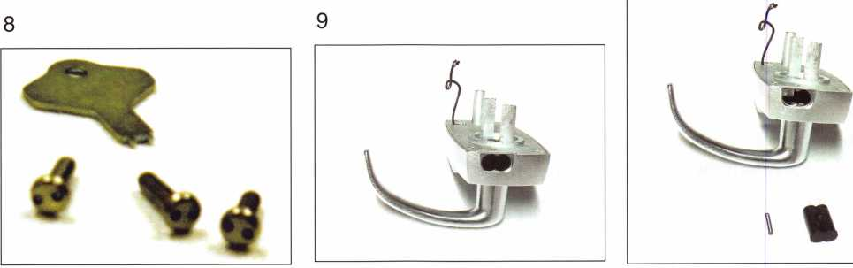

Keynotes • May 2004

**2**

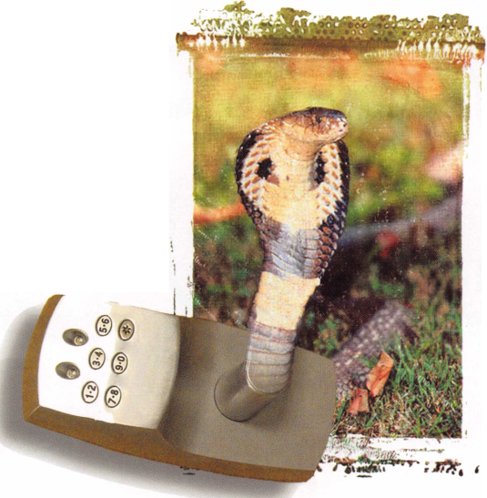

Traditional L o c k s m i t h i n g :

By Greg Brandt, CML

UNSTICKING



The wafer (disc) tumbler cylinder as we know it has existed for over 130 years. This design did not become popular until the early 1930s, as suitable casting alloys had yet to be developed. “Disc tumbler” is the pre­ferred term, but you can’t easily refer to a single tum­bler as a disc, so we call it a wafer here. Even though shapes and dimensions vary, the cylinder is almost always zinc alloy (Zamak), and the tumblers almost always brass. The die-cast construction makes this design economical to produce, because the alloy is inexpensive, and there is little or no machining of parts.

Any product design carries with it a set of typical problems. Our focus is on automotive applications, because the wafer design has always been popular with cars. At this point, virtually all vehicles use wafer locks. The problem we are concerned with is tumblers that either stick or otherwise become nonfunctional. Within the automotive environment, these problems are common.

Wafer tumblers become immovable primarily due to metal deformation or corrosion. Metal deformation is caused by repeated insertion of a key. The rubbing action of the key on the inside of the keyway progres­sively deforms the soft zinc alloy and pushes metal into the tumbler chambers. Even though this is a result of use, deformation is different from wear.

Corrosion is chemical deterioration of the metal sur­faces due to inadequate lubrication, lack of use, and exposure to the elements of nature. Typically, oxides form, which bind moving parts together. Tumblers may also stick simply due to the lubricants becoming dirty, old and thick, but that is normally rectified by cleaning and application of new lubrication. Additionally, there are conditions and types of abuse that may cause tumblers to bend.



Keynotes • May 2004

CASE EXAMPLES

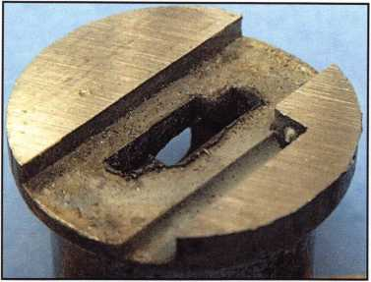

We will begin by looking at a few examples of defor­mation. Photo i is the plug from the ignition of a Range Rover. I have sawed the plug, with the view looking from the rear at the first tumbler chamber. You can see how metal around the edge of the keyway has reshaped and protrudes into the chamber. At some point, this pushes into the tumbler, and it fails to return under the force applied by the spring. As a side note of interest, observe the conical protrusion formed to seat to the spring.

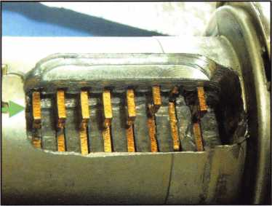

Photo 2 is the ignition plug from a 1998 Pontiac Grand Am. I have carefully milled a window on the side opposite the sidebar. The tumbler in the third position is partially stuck, and the tumbler in the sec­ond position is stuck completely This is a very com­mon problem with these locks, and you can realize why some production locks have the tumblers in posi­tions 2 and 3 omitted. The arrow points to a ledge formed by the keyway warding. If you follow it to the front, you will see how it is excessively worn and slightly deformed near the first tumbler positions.

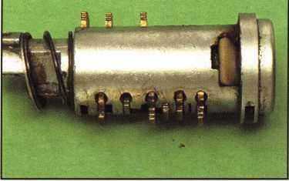

I have encountered sticking Volkswagen tumblers on locks back to the early 1970s. Historically, VW igni­tion locks are mounted in a way that causes one to reach around the steering wheel more than some cars. The tendency is to insert the key at an angle to the axis of the keyway, and that causes deformation. Photo 3 is the plug of a Volkswagen ignition lock, with no key inserted. There are 10 tumblers in these locks, but from about the early to mid 1990s, the second tumbler was replaced with a steel guide, as in this one. The tumbler in the fourth position is stuck and protruding on the wrong side, as well as the tumbler in the sev­enth position, being stuck flush and not protruding.

The object of releasing stuck tumblers is generally to allow a key to operate the lock in order to remove and disassemble it. Repairs can usually be made, or in some cases, the lock may need to be replaced. Anyone in the service business becomes a junior engineer. We engineers differ on whether to repair or replace. We will also differ on how best to make a repair.

No matter if the malfunction is a result or deforma­tion or corrosion, the methods used to unstick tum­blers are essentially the same. If corrosion is a factor, lubrication is a necessity. A discussion of lubricants may incite a small argument among a group of lock­smiths. The factory lubricant for virtually all automo­tive disc tumbler locks is some flavor of grease. I use several types of lubricants, but servicing corrosion requires a light-bodied solution to permeate every nook and cranny. Lock-Ease® is a favorite for corrod­ed locks, as well as permanent lubrication for certain types of cylinders.

Keynotes • May 2004



PROCEDURE

In the simplest cases, tumblers may be freed by inserting the key and rapping on the bow. The handle of a screwdriver works well here. I have used this many times, and it is a method I have advised strand­ed customers to use. There are many situations where rapping will never work. It is at that point we need to use tools. We need a way to probe, poke and dig into tumblers so they may be forcibly moved. Once repeated movement is achieved, you can generally insert a key and rap to allow operation. Almost always, I feel the need to first look into the keyway and depress tumblers with a reader to determine the condition of the lock.

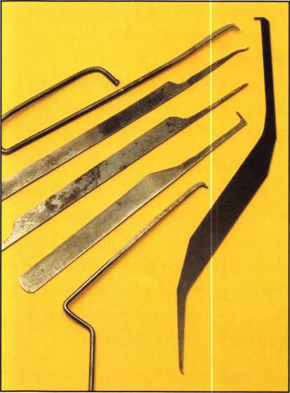

Photo 4 shows some of the homemade tools I have used in the past, along with a new tool available from Peterson Manufacturing, on the right. The Wafer-Doc comes with the new set of Wafer Readers, or is avail­able separately. As you can see, the Wafer-Doc has two ends and looks goofy. The peg end is for pushing against the inside of a tumbler, and the rhino end is for gouging and scraping. This tool is far easier to use than the stuff I previously made.

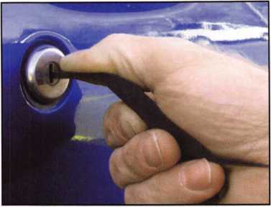

Most non-sidebar locks have tumblers that complete­ly surround the key blade. This means the opposing side (opposite of what contacts the key) can be probed and pushed. Illustration A shows a lock with tumblers on only one side of the keyway, and the first two tumblers stuck. The technique is to use the peg end of the Wafer-Doc (or whichever peg tool you wish) to probe into the chambers of the opposing side. Push the peg into each chamber as far as it will go. The peg technique requires no visual inspection during the process, and is done simply by feel. When a stuck tumbler is located, you may need to force it down (or up) several times to loosen it. Photo 5 shows how easy it is to hold the tool and probe the cham­bers. Most of the time, when a tumbler is manipulat­ed, it will stick again when the key is inserted. With deformation, one trick is to move the tumbler once, then use the peg behind the tumbler and pull (as depicted in Illustration B). This forces the tumbler against the deformed metal, which may slightly relieve the binding.

With corrosion, you generally need to work the tum­bler several times. In just a few cases, the condition may be so bad that loosening tumblers through the keyway proves impossible. Corrosion is most common with trunk locks, probably because of habitual use of the inside trunk release and air flow at the rear of the car.

Sticking tumblers in certain sidebar locks may be more difficult to service. This does not mean the closed tumbler design such as Ford 8-cut or late

**30**

Keynotes • May 2004



Chrysler, but rather the open design that has been  
common to General Motors 6-cut, and similar types.  
The problem is there is no surface on which to push.  
The rhino end of the Wafer-Doc curves to a point in  
order to allow you to dig, pry and scrape (as shown in  
Illustration C). Using the rhino end of the tool effec-  
tively must be done along with viewing where the tip  
of the tool is in the lock. The use of lighted magnifi-  
cation is in order for this operation. There are very  
few locks on which I don’t first use an otoscope to  
look into the keyway.

The technique is to use a pointed tool such as the  
rhino end of the Wafer-Doc, and scrape the tumbler  
chamber using twisting and scrubbing motions. You  
may be able to turn the tool sideways and dig into  
the side of the tumbler in order to force movement.  
It is also possible to use the point to gouge into the  
face of the wafer and pry. With the subject lock in  
Photo 2, I was able to scrape metal using a combina-  
tion of both ends of the tool. The peg was twisted  
and worked into the side of the chambers where  
deformation was the worst.

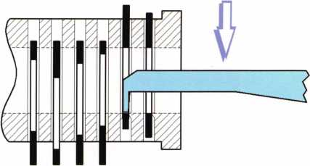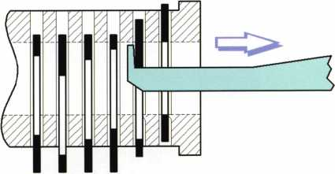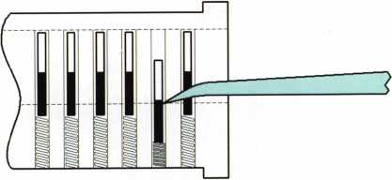

No matter if the malfunction is a result of

deformation or corrosion,

the methods used to unstick tumblers

are essentially the S3J11C.

Keynotes • May 2004

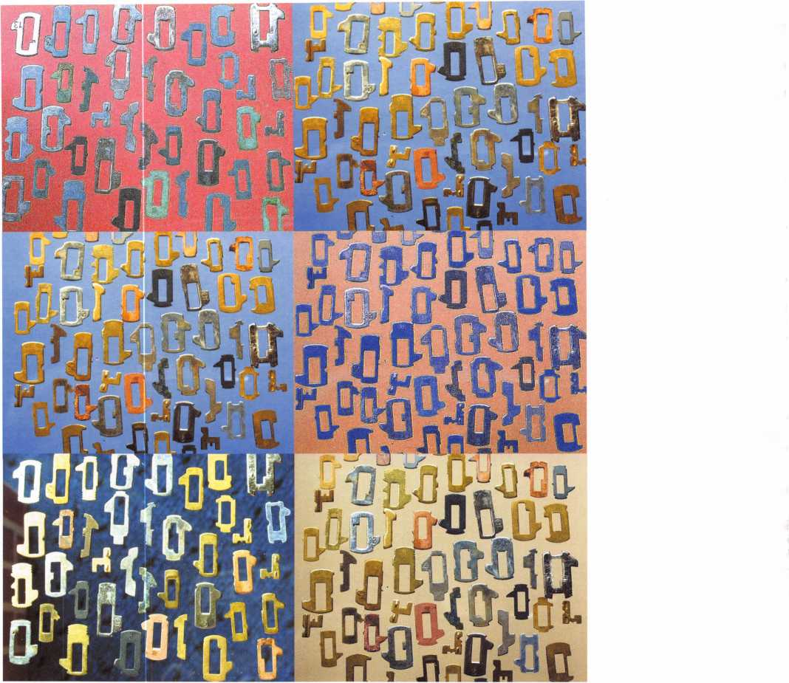

REPAIRS

In some cases, the cylinder or plug is inexpensive and would normally be stocked by the locksmith.

Repairing versus replacing is always a balancing act, with many factors to consider. I almost always repair a cylinder if wear is not excessive. Repairing allows you to complete a job without the cost of a new cylinder, or the time in ordering a lock and scheduling a second session with the customer.

Chamber deformation may be corrected with a thin file. Most tumblers are from .030 to .040 inches thick, with the chambers naturally a little larger than the tumbler. Your small file may not be thin enough to enter a chamber. Photo 6 shows the use of a small needle file, which I thinned by grinding the cutting surface from one side (not visible). A word of advice: Be thorough, and check your work. I have discovered, at times, that I must have tilted the file and not removed all the protruding metal.

Keynotes • May 2004

Corrosion may be relatively mild or severe. There have been many cases of corrosion in which I felt the lock would function without further service, after tumbler manipulation and lubrication. The very bad cases need complete disas­sembly, drawing the tumblers over a flat file (if new tumblers are not available), and sometimes filing the chambers. I have found a diluted solution (1:1) of muriatic acid is an excellent way to quickly dissolve the oxides on a plug. Photos 7 and 8 show before and after an acid treatment. Use acid judiciously, as it will dissolve the metal too, but at a lesser rate. In order to use acid, you must first degrease the part, as lubricants will insu­late the acid from the oxides to be removed. Brake cleaner, naptha, or any number of other solvents work to remove some greases, but you may also need to follow with soap and water. Many lubri­cants will not dissolve with petroleum solvents, and can just be hard to remove.

All automotive locksmiths encounter sticking tumblers. If your methods have only been rapping and lubrication, I encourage you to explore. There are techniques and tools available that can greatly simplify getting from point A, to job complete.

New from Adesco. The Latest Technology at Affordable Prices!

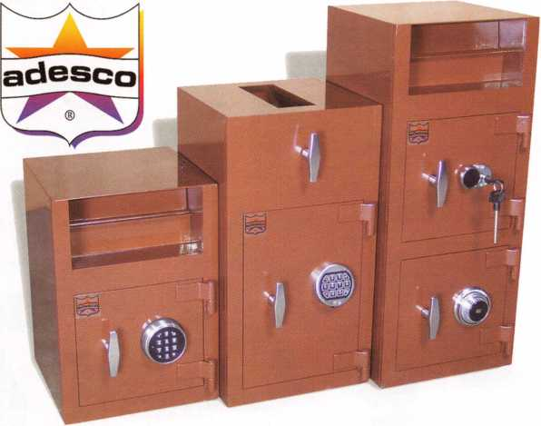

**Special Introductory Pricing and  
Promotions Available Now.**

Introducing the all new Business Deposit Safes from  
Adesco. Safes feature precision plasma cut doors and  
solid 1/2" monoframe faceplates. Door jams are reinforced  
and tied to safe sides. Postal drops offer our famous  
recessed baffle technology. *LaGard’s all new Group 2M

combination locks and spy-proof dials included  
at no additional cost. All these features  
and more at an economy price!

Call your Adesco distributor today.

*When available

(800) 694-9340 • [www.adesco.com](http://www.adesco.com) • [safes@adesco.com](mailto:safes@adesco.com)

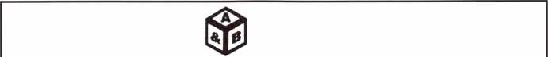

SAFE CORPORATION

MANUFACTURES OF QUALITY DEPOSITORY SAFES AND CHESTS

DISTRIBUTING FROM WAREHOUSES IN

* LOS ANGLES**,** CA
* CHICAGO, IL
* GLASSBORO, NJ

A & B is now a stocking distributor for Mutual Safes ,

featuring

11 -

AB-4-30-3S AB-9-2 WS 10-2

Chose from over 75 models in stock

We ship your order within

24 hours

See us

*of [www.a-bsafecorp.com](http://www.a-bsafecorp.com)*800-253-1267  
Fax 856-863-1208

CALL FOR YOUR CATALOG TODAY

Keynotes • May 2004

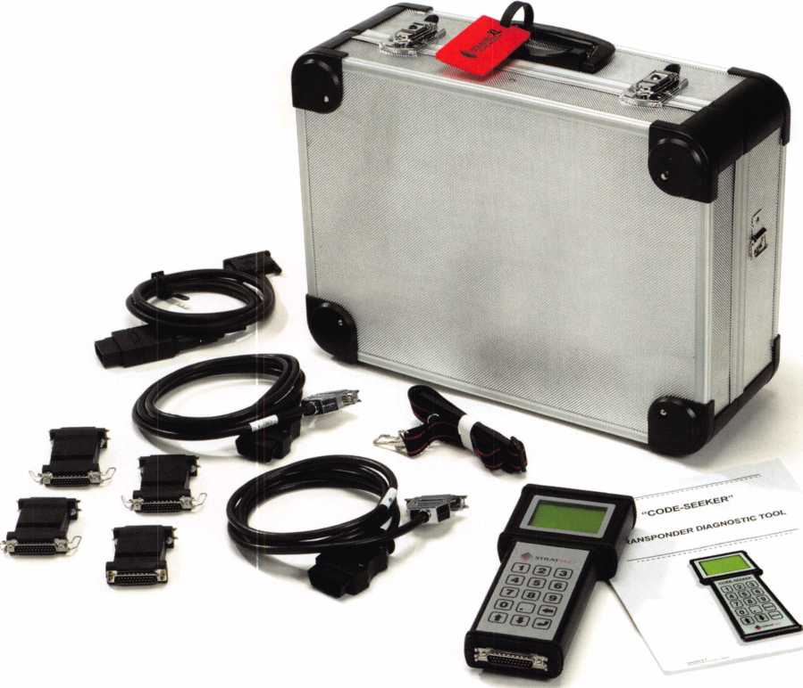

Takin’ it to the Streets:

Tracking the Reception of Strattec’s New Code-Seeker

With the introduction of STRATTEC Security Corporation’s new product, CODE-SEEKER™, we wanted to find out how the industry is receiving the new product. We visited Gene Schaed, owner of Apex Key & Lock in Racine, WI, to find out just what the inside word is. Gene’s been in the business for more than 34 years, and if anyone has an opinion on a new product, we’re thinking it’s him. Here’s how our discussion went:

Keynotes • May 2004

KEYNOTES: How much of your business is automotive?

I’d say about 30 percent.

KEYNOTES: Over the years, how have you seen that percentage grow or decrease?

eventually go by the wayside, as far as really being any competition for the locksmiths. With all the elec­tronics that are available, you are going to set your­self apart by offering a lot more, simply because you have the technology and the ability — it’s just the way it is. You have to deal with the technology that’s available because if you don’t, eventually somebody else will come in and do it.

You know, it’s constantly growing.  
At our shop, automotive is one of  
the most lucrative parts of lock-  
smithing, and the potential is  
growing. With that in mind,  
I began to realize that at this  
stage, you really need to either  
dive into that portion of the busi-  
ness or get out.

KEYNOTES: Do you feel that hav-  
ing tools that allow you to work on  
vehicles that are equipped with  
transponder technology are nec-  
essary?

Absolutely, without a doubt. In fact, if you don’t adjust to the industry transitions, you won’t be in the busi­ness much longer. People these days are going to go someplace where they can get the entire job done, not piece-by-piece. One-stop shopping. It’s kind of like only doing half of the job when people are look­ing for the whole thing. Before CODE-SEEKER™, we could fit the key here, but then you have to go someplace else to get it programmed; that’s not going to work anymore. I believe that hardware stores and a lot of the others shops like that will

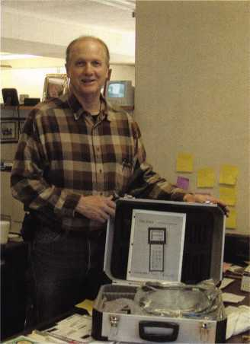

KEYNOTES: How long did you  
research CODE-SEEKER™  
before you made the purchase?

Oh, a real long time — about two  
hours. Two different suppliers  
told me about CODE-SEEK-  
ER™, and one said “Well,  
STRATTEC has a machine that  
they’re coming out with, but they  
aren’t going to sell it to us.” Now,  
he wasn’t so disheartened when  
he told me about it; as a matter  
of fact, he faxed me the informa-  
tion on it. Then I checked with

one of my suppliers in New York and found out it was  
cheaper than another brand. I also liked the concept  
that $1 of every transponder key will be applied to  
the overall cost and upgrade over the next year,  
which just seems like great sense to me.

KEYNOTES: What made you make the move to pur­chase CODE-SEEKER™?

First of all, as I mentioned eariier, automotive is the most lucrative business for me right now. I was just



Keynotes • May 2004

saying the other day that if I was coming into the  
locksmith business right now, I would focus all my  
attention on automotive. The profit is very good in the  
automotive sector. People have a love of cars and  
they don’t hesitate to spend money on them.  
Secondly, we’re just now seeing cars that use  
transponder keys at auctions and used car dealer-  
ships. These cars are no longer covered by their  
manufacturer’s warranty. As we all know, under war-

ranty, the dealer provided the serv-  
ice; now that the warrantees are end-  
ing, dealers and auction houses are  
coming to us, and I want to build and  
capitalize on those relationships.

Within the next five to six years, I see  
a growth in our profit in this area. A  
significant growth and significant is  
good. If you don’t fill that void, some-  
one else will. CODE-SEEKER™ has  
gotten me enthused about the lock-  
smith business all over again. I don’t  
know a lot about electronics, but I like  
working on cars.

KEYNOTES: How does STRATTEC CODE-SEEK­ER™ compare to other products in the industry?

Two things come to mind: cost and program. CODE­SEEKER™ is currently less expensive than compa­rable products. On top of that, they give you a $1 dollar credit on every transponder key that is purchased, which is applied to the cost of future upgrades.

KEYNOTES: Have you been satisfied with the serv­ice you received from STRATTEC?

You know, they talk about their 24/7 technical sup­port and I’ve only had to call them once. If that was

an example of what my relationship with them will be  
like with this product, I’m again glad I made this  
investment. I mentioned earlier about the conven-  
ience of being able to contact STRATTEC directly. In  
our business, it really is about getting matters taken  
care of in a timely manner, and the 24/7-customer  
service that STRATTEC offers is a perfect example  
on addressing this need and doing it well. I’ll keep  
you posted, but so far so good.

KEYNOTES: What do you think about the  
manuals supplied with your CODE-  
SEEKER™?

Well, for someone like me who finds  
themselves “technology challenged,” I  
found the manuals a breeze. There were  
a few times that I did turn to my son-in-  
law for direction, but the manuals really  
offer easy-to-understand, step-by-step  
instructions.

KEYNOTES: What are your feelings on  
STRATTEC’s idea of marketing this tool

directly to locksmiths?

When I called back the supplier that originally told  
me about CODE-SEEKER™ and told him I moved  
forward with it, I’m sure he had to ask himself what  
he got out of the deal. Surprisingly, if it weren’t for the  
suppliers, I wouldn’t have known about it. I saved a  
couple thousand dollars in the process by going with  
CODE-SEEKER™ and I believe buying direct from  
STRATTEC had a lot to do with that low price.

KEYNOTES: With the purchase and use of CODE-  
SEEKER™, how has that affected the orders to your  
distributors for transponder keys?

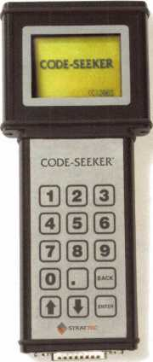

Keynotes • May 2004

That’s a great question - in fact, the answer address-  
es what the supplier has to gain. One of my suppli-  
ers is thrilled because he realizes that the more I use  
CODE-SEEKER™, the more keys I will buy from  
him. Yes, the suppliers miss out on the initial sale of  
the product, but they’re realizing they win with the  
jump in purchase of keys. In fact, one supplier has  
said he’d be building up his inventory of keys for us.

KEYNOTES: Do you think  
this is a good move for the  
locksmiths, and why?

Cost wise, STRATTEC’s  
approach is a win-win for  
everyone. With this prod-  
uct, I can continue to serv-  
ice the automotive busi-  
ness, which means I make  
more money through more  
business. More business  
means I buy more keys and  
that means more business  
for my supplier. I realize

that the suppliers think they are missing out on their end. But if we have a problem with the product, we can go directly to STRATTEC 24/7 rather than taking up the time of my supplier. That saves me time, money and in the end, saves my customers money.

KEYNOTES: How soon do you believe you will have recovered your investment?

Well, I plan on doing some advertising on the fact that I have CODE-SEEKER™. The small amount that word has gotten out so far has been great. We figure that once our mailing goes out, to auctions and used car dealers, we will really see a dent in the pay-off.

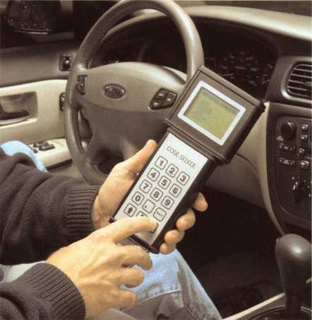

KEYNOTES: Would you recommend this tool to  
other locksmiths, and why?

Yes and no. Yes because, and I know I’ve said this  
before, if locksmiths don’t understand that this tech-  
nology is really the future and a lucrative future at  
that, other locksmiths going in this direction will leave  
them in the dust. And no, because I would prefer that

no other locksmiths in

southeastern Wisconsin  
purchase CODE SEEK-  
ER™. I really don’t want the  
company, if you know what  
I mean.

KEYNOTES: Finally, how  
have you seen the industry  
change and in what direc-  
tion do you see it going?

Two words: automotive and  
technology. Cars are get-  
ting more and more techno-  
logical and you need to

either keep up or get out. My new slogan should be  
“Have CODE-SEEKER™, Will Travel.” Think of the  
percentage of cars that are no longer under warran-  
ty and what do you do? Auctions are more popular  
than ever. What do you do for extra keys? Not only  
can I take care of my clients, but I can also outsource  
my services to a whole new industry. Keys aren’t like  
they were in the old days. Technology has changed  
that. It used to just be only import cars used  
transponder technology, but that’s changing. Most  
cars are going the transponder route and CODE-  
SEEKER™ addresses those cars.

Keynotes • May 2004

**3**

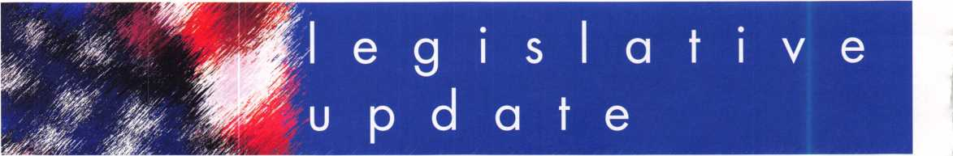

**President Bush Pushes Association**

**Health Plans; Senate**

President George W. Bush continues to promote the Association Health Plan legislation (Small Business Health Fairness Act of 2003 - S. 545/H.R. 660) as a key com­ponent of his health care agenda. The President spoke in favor of the AHP legislation at a forum of small business representatives at the U.S. Chamber of Commerce in Washington, DC, on March 16, 2004. Also, Bush Administration officials have indicated that the President is urging the Senate to vote on the AHP bill later this year. Bringing the AHP bill to a vote will be very helpful towards the goal of Senate approval, because many Senators refuse to take a position until forced to vote on some issues. ALOA's Healthcare coalition once again commends President Bush for his outstanding leadership and efforts in pushing the Senate to join the House in approving the AHP legislation.

Meanwhile, the Senate Republican Task Force on the Uninsured is continuing its efforts to explore and develop principles and/or legislative options to address the prob­lem of the more than 40 million uninsured Americans. The Senators on the Task Force have held several meetings, and Senators Jim Talent (R-MO) and Olympia Snowe (R- ME) continue to advocate that AHPs be included in the Task Force's final product because of the potential of AHPs to expand coverage to millions of uninsured small business workers. Senator Talent has indicated that many of the Senators on the Task Force are very "open to dis­cussion" about the AHP legislation, and that progress has been made in getting them to understand the issue.

Sources indicate that the Task Force is working towards a self-imposed mid-April deadline for wrapping up its work. However, there continues to be much uncertainty over when and how the Task Force will act. Senator Judd Gregg (R-NH), the Task Force Chair, is under great pres-

**Still Deliberating**

sure to move forward as soon as possible.

While the Task Force Senators have been receiving many contacts in support of the AHP legislation, ALOA Coalition members are strongly urged to continue efforts to lobby these Senators to endorse S. 545. Letters and/or calls to Senators and staff should request that the Senator cosponsor S. 545 and also that the Task Force endorse the AHP bill. Organizations should also continue lobby­ing other Senators not on the Task Force and urge them to cosponsor S. 545 (see attached target list). The Senate will be in recess from April 10 through April 19, so now is a great time to schedule meetings with Senators back in their home state.

Also, the Senate Finance Committee held a hearing to review the growing problem of unauthorized and bogus health plans that can be extremely damaging to both employers and workers. The Senators at the hearing reviewed the results of a General Accounting Office report examining this problem. Ann L. Combs, Assistant Secretary of Labor for Employee Benefits Security, testified that the Association Health Plan legislation (S. 545), by providing associations of employers with a new means of establishing health plans, and by clarifying the regulatory status of AHPs, would help reduce the problem of unau­thorized health plans. Assistant Secretary of Labor Combs, along with Labor Secretary Elaine Chao, has been a very strong advocate for the AHP legislation, and is to be commended for her strong support and efforts.

House of Representatives

On the House side, there has been some discussion that the House might develop an "uninsured package" of leg­islative initiatives, similar to what the Senate Task Force is

Keynotes • May 2004

pursuing. If such an effort does transpire, the AHP bill (H.R. 660) that has already passed the House will surely be included. If the House does move a legislative propos­al of this nature, it will help put further pressure on the Senate to act on this issue this year.

House Education and Workforce Chair John Boehner (R- OH) and Employer/Employee Relations Subcommittee Chair Sam Johnson (R-TX), recently sent a letter to Senator Gregg and other members of the Senate Task Force urg­ing them to endorse the AHP legislation. With the depar­ture of the AHP bill's chief Republican sponsor, Rep. Ernie Fletcher (R-KY), from Congress (who is now Governor of Kentucky), Reps. Boehner and Johnson are the AHP bill's foremost Republican champions in the House. TAHC com­mends them for their continued strong leadership on behalf of the AHP legislation.

USA Today Advertisement

The National Federation of Independent Business is launching a new grass roots petition drive to generate more pressure on Senators to support the AHP bill. As part of this effort, NFIB will run an advertisement in USA Today on April 1, 2004, on behalf of all organizations that support the bill. NFIB is using the term "Small- Business Health Plans" as synonymous with Association Health Plans because this term appears to resonate better with its members. NFIB will also hold a press conference announcing the petition drive on April 1, at 1 1:30, on Capitol Hill.

LEGISLATIVE  
ACTION NETWORK

You’re a professional locksmith,  
not a professional lobbyist.

You can’t be on the steps of every state capitol and walking the halls of the federal government to protect your profession, but...

WE CAN!

The ALOA Legislative Action Network (LAN) needs Your support for the Voice of Our Profession.

The ALOA Legislative Action Network is constantly working to influence legislation that’s important to the locksmithing profession. We are working in your best interests to promote legislation that will have a positive impact on our proud profession; while preventing or limiting legislative efforts that are harmful. To continue, we need your help to ensure the success of our legislative program for 2004!

If you contribute $25-$99.99 to the Legislative Action Fund, you automatically become a member of the Legislative Action Network (LAN). The LAN is an important tool in raising the standards of our profession through the legislative process by making sure that locksmiths have the final say in how our industry will be run. As a LAN member, you will receive:

* The Legislative Action Network Update alerting you to important legislation in your state and around the country.
* Networking opportunities with ALOA members who share the belief that legislative involvement is important to the effectiveness of our association.
* A listing of your state representatives and senators including capital and district addresses, and phone and fax numbers on both hard copy and disk.
* A comprehensive guide to lobbying in your state capital, so you can be the "voice of ALOA" to legislators.
* LAN stationary and envelopes for sending official letters to legislators, lobbying on ALOA’s behalf.
* A lapel pin designating you as a special ALOA LAN member,
* Recognition in Keynotes magazine.
* An invitation to an exclusive reception at the annual ALOA convention for LAN members.

When you donate $100 or more, you become part of the heart of the legislative program through LAN membership and receive the following:

* A reserved place of distinction on the special LAN Council
* Discounts on ALOA bookstore items and a 10 % rebate on all ACE classes.
* Complimentary Legislative Convention merchandise.
* It’s easy to do Your part...just join TODAY!!

NOTE: Contributions or gifts to the Associated Locksmiths of America, Inc. are not tax deductible as charitable contributions or as business expenses under IRC - 162(e).



Keynotes • May 2002

Classifieds



EMPLOYMENT

FOR HIRE

Product Manager

Kaba llco Corp., the world leader in the manufacture of key blanks, key cutting machines, and replacement cylinders, is seek­ing a Product Manager, responsible for the strategic direction and marketing of automotive transponder keys and equipment. The ideal candidate will possess a strong understanding of auto­motive diagnostics and automotive key generation and program­ming.

Responsibilities:

Direct and perform all aspects of product development, product changes and product promotions.

Manage and communicate sales and technical information for internal and external business customers.

Develop and maintain a pricing program that balances competi­tive challenges and at the same time meets revenue growth and profit objectives.

Prepare the marketing plans for assigned product lines and rec­ommend changes to meet market and competitive conditions.

Conduct field test of product software and hardware to insure market needs are met and design training programs for distribu­tion and end users to understand the applications of each.

Leads internal research efforts to identify automotive and security trends pertaining to the product line.

Managing all elements of the product line support requirements including merchandising, advertising, literature, website informa­tion, etc.

Skills/Education:

* Four year degree in Business Administration, Marketing or related technical field.
* Minimum of four years experience as Product/Brand Manager/Engineer for a technical product related to automo­tive diagnostics or automotive security.
* Strong written and oral communication skills.
* Proven ability to prepare and implement business plans and strategic assessments.
* Must have proficient Microsoft Office Suite experience in Excel, Word, PowerPoint

Interested candidates may send their resume with salary history in confidence to:

Human Resource Department, Kaba llco Corp., P.O. Box 2627, Rocky Mount, NC 27802, fax: 252-446-4702, or e-mail to [resume@irm.kaba.com](mailto:resume@irm.kaba.com) An EOE M/F/H/V.

EXPERIENCED LOCKSMITH WANTED

Harris County is seeking an experienced Locksmith For informa­tion please see website

<http://co.harris.tx.us/hrrm>

Or call (713) 755-5906 all applications must be applied in per­son *1310 Prairie, 2nd floor, Houston, Texas 77002

BRANCH MANAGEMENT MANAGER

Safemasters, an established company, has an outstanding oppor­tunity in the Boston area for a results driven manager with a proven record. Preferred candidate will have, supervisory and admin skills, strong people skills, P&L exp.& sales ability. Responsibilities include directing & motivating a growing team including locksmiths and dispatch & inventory, and growing the market through sales, productivity & profits.

Prior experience in physical security, alarms, access control, or locksmith field helpful.

Our associates enjoy an equitable salary plan plus generous incentive and bonus plans for results oriented managers, and comprehensive benefit plans including 401 (k) and company matching plan. If you have a proven record and are looking for a company that both supports and encourages associates, forward your resume with salary history today.

Safemasters - Operations #93 Email: [hr2@safemasters.com](mailto:hr2@safemasters.com)

FAX: 800-233-2454 attn. Bryan Shaffer - #93 Voice Mail: 800-295-4702 x154

LOCKSMITH FOR HIRE

Immediate opening with a full-service locksmith & security com­pany located in Aurora, CO. Seeking a Senior Service Technician proficient in all phases of locksmithing including safes and electronics. Company vehicle will be provided including all maintenance and fuel on vehicle. Benefits include a 401-K plan, Health Insurance, Vacation and Holiday Pay. Salary negotiable.

Contact: Sheila or Susan • Arapahoe County Security Center

15200 E. Iliff Ave • Aurora, CO 80014 • phone: 303-745- 5500

fax: 303-745-5567

LOCKSMITH FOR HIRE

Locksmith, South Orange County, CA. Excellent opportunity for experienced technician in access control, safes and standard locksmith work. Van and all tools provided. Excellent pay and benefits. Send resume or call Tony's Locksmith at 949/492- 5700. Fax to 949/492-0246.

STAR SAFE AND LOCK

Star Safe & Lock, a 57-year-old commercial locksmith company, is looking for a qualified locksmith and safe technician in South Los Angeles County to South Orange County, California area.

We will provide continuous training for the right individual but knowledge of locksmith basics is a must. Health and Dental insur­ance programs. Fax 801-469-1077. Email [info@starsafe.net](mailto:info@starsafe.net)

EXPERIENCED LOCKSMITH WANTED

Harris County is seeking an experienced Locksmith For informa­tion please see website

<http://co.harris.tx.us/hrrm>

Or call (713) 755-5906 all applications must be applied in per­son • 1310 Prairie, 2nd floor, Houston, Texas 77002

BRANCH MANAGEMENT MANAGER

Safemasters, an established company, has an outstanding oppor­tunity in the Boston area for a results driven manager with a proven record. Preferred candidate will have, supervisory and admin skills, strong people skills, P&L exp.& sales ability. Responsibilities include directing & motivating a growing team including locksmiths and dispatch & inventory, and growing the market through sales, productivity & profits.

Prior experience in physical security, alarms, access control, or locksmith field helpful.

Our associates enjoy an equitable salary plan plus generous incentive and bonus plans for results oriented managers, and comprehensive benefit plans including 401 (k) and company matching plan. If you have a proven record and are looking for a company that both supports and encourages associates, forward your resume with salary history today.

Safemasters - Operations #93 Email: [hr2@safemasters.com](mailto:hr2@safemasters.com) FAX: 800-233-2454 attn. Bryan Shaffer - #93 Voice Mail: 800-295-4702 xl54

WANTED TO BUY/SELL

WANTED TO BUY

Safemasters Co. Inc. is seeking to acquire an additional lock­smith business in the greater Boston area. If you are an owner and would like to explore the possibility of selling your business, we would be interested in talking with you. Confidentiality assured. Contact Bryan Shaffer at [hr2@safemasters.com](mailto:hr2@safemasters.com), or voicemail 800.295.4702 (ext. 154).

FOR SALE

Mobile Locksmiths Business. 2002 Freightliner Sprinter. HPC Code Machine and code books, extra cutters. Lots of tools.

Many years in area. Growing business. Buy and go to work, completely ready. Located in NE Maryland. Call 888/339- 5625. Priced to sell quickly. ALOA Member.

BLUE PUNCH

key machine #BP201, set up to cut Best "A" key blanks. Like new. $375. Call 972/727-2780.

WANTED TO BUY

Safemasters Co. Inc. is seeking to acquire an additional lock­smith business in the greater Boston area. If you are an owner and would like to explore the possibility of selling your business, we would be interested in talking with you. Confidentiality assured. Contact Bryan Shaffer at [hr2@safemasters.com](mailto:hr2@safemasters.com), or voicemail 800.295.4702 (ext. 154).

Classified Advertising Policy

Classified advertising space is provided free of charge to ALOA members, and for a fee of $.60 per word, $15 minimum for non-members. Classified ads may be used to adver­tise used merchandise and overstocked items for sale, "wanted to buy" items, business opportunities, employment opportunities/positions wanted and the like. Members or non­members wishing to advertise services or new merchandise for sale may purchase a "Commercial Classified Ad" for a fee of $1.30 per word, with a minimum of $40. Each ad will run for two issues. For blind boxes there is a $5 charge to members and non-members. All ads must be submitted in writing to the ALOA office by the fifteenth of the month, two months prior to issue date. Send to Keynotes Classifieds, 3003 Live Oak St., Dallas TX 75204-6186. ALOA reserves the right to refuse any classified advertisement that it

deems inappropriate according to the stated purpose of the classified advertising section.

BUSINESS FOR SALE

SMALL MOM-AND-POP

locksmith and glass business for sale in Golden Valley, AZ. Retirement is forced for health reasons. On busy US Highway 68. Golden Valley is between Kingman, AZ, and Laughlin,

NV. In fast-growing Mohave County. Leased shop. Dodge Ram Van 2500. Both well-equipped and stocked. $65K plus equip­ment and inventory. Asking $48,900. All reasonable offers will be considered. New money only. Call 928/565-2294 or e-mail inquiries to [lmburks@ctaz.com](mailto:lmburks@ctaz.com).

BUSINESS FOR SALE

Growing East Tennessee locksmith business, established 1987. Supports three locksmiths, two fully equipped vans and build­ing on corner lot fronting main highway through town. Shop customers, residential and commercial accounts ready for someone to take over. Call 423-586-3101. Monday-Friday. 8:00 a.m. to 5:00 p.m., EST.

From: kimilu

Sent: Wednesday, April 7, 2004 1:00 PM

To: 'Jim Desimone'; 'Betty Henderson'

Subject: Emailing: Yankee Show Ad to run in May issue

of Keynotes

IN-STOCK...MORE SAFES

***FREE Freight Program***

***(30 States)***

AMSEC FireKing

Qardall hayman

MEIUNK y/CPOR

**TURfl 1©**

**WHOLESALE SERVICE**

800**-**848-9790

BUSINESS FOR SALE

Growing East Tennessee locksmith business, established 1987. Supports three locksmiths, two fully equipped vans and build­ing on corner lot fronting main highway through town. Shop customers, residential and commercial accounts ready for someone to take over. Call 423-586-3101. Monday-Friday. 8:00 a.m. to 5:00 p.m., EST.

25+ Function

JUtulti-Tool

**—** Lifetime Warranty **—**

FOR LOCKSMITHS ONLY

* 25 Functions
* Services Schlage, Baldwin,  
  Corbin/Russwin, Lori,  
  Adams Rite, Master  
  padlocks, Medeco, Arrow,

Jackson crossbars and

many more!

Call Toll Free...

888-634-LOCK

[www.lockmantools.com](http://www.lockmantools.com)



**THE HINGE DOCTOR**

**by GKL Products**

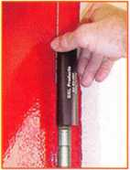

**HA1 For  
Standard**

**Commercial**

**4-1/2" x 4-1/2’**

**Butt Hinges**

**HA2**

*"The HULK"*

**For Residential Hinges**

**COMING IN  
SEPTEMBER**

**HA3**

**For Ball-**

**Bearing &**

**Commercial Hinges**

**The Hinge Doctor is a great way to repair those sagging metal  
doors. Slip the tool over the hinge and open the door an inch**

**or two past the point where the tool binds against the**

**hinge, remove the tool and check the door,  
which should now be working properly.**

**If you're a locksmith these tools  
will turn a profit the 1st time you  
use them!  
Uses - schools, hospitals,**

**commercial buildings, storefronts  
with butt hinges, office doors, new**

**construction, door alignment, sagging  
doors, jail cells, anywhere there are  
commercial grade hinges.**

**HA4**

**For Prison**

**& institutional**

**Hinges &**

**Spring Hinges**

Over

**10,000**

Satisfied

Customers

US Patent

#6450003

**[www.hingedoctor.com](http://www.hingedoctor.com)**

800-924-5397

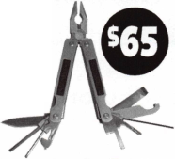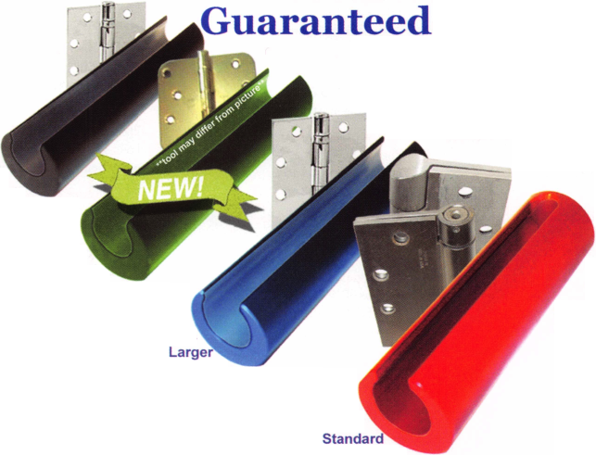

Distributor

**ADI Inc**

Phone: 631-692-1000  
Fax: 631-692-3011

**Accredited Lock Supply Co**

Phone: 800-652-2835  
Fax: 201-865-0030  
[www.acclock.com](http://www.acclock.com)

**Ace Lock & Security Supply**

Phone: 800-223-5625  
Fax: 908-688-2442  
[www.acelock.com](http://www.acelock.com)

**Andrews Wholesale Lock Supply**

Phone: 717-272-7422  
Fax: 717-274-8659  
[www.andrewslock.com](http://www.andrewslock.com)

**Boyle & Chase Inc**

Phone: 800-325-2530  
Fax: 800-205-3500  
[www.boyleandchase.com](http://www.boyleandchase.com)

**Clark Security Products**

Phone: 888-784-131 1  
Fax: 619-718-7333  
[www.clarksecurity.com](http://www.clarksecurity.com)

**Cook's Building Specialties**

Phone: 505-883-5701  
Fax: 505-883-5704

**Dire's Lock & Key Company**

Phone: 303-294-0176 Fax: 303-294-0198

**Direct Security Supply, Inc.**

Phone: 800-252-5757 Fax: 800-452-8600

**Discount Key Machines.Com/Busch**

Phone: 800-332-8724 Fax: 407-363-4666

**Doyle Security Products**

Phone: 800-333-6953 Fax: 612-521-0166 [www.doylesecurity.com](http://www.doylesecurity.com)

**Dugmore and Duncan, Inc.**

Phone: 888-384-6673 Fax: 888-329-3846

**E. L. Reinhardt Co., Inc.**

Phone: 800-328-131 1 Fax: 651-481-0166 [www.elreinhardt.com](http://www.elreinhardt.com)

**Ewert Wholesale Hardware**

Phone: 800-451-0200 Fax: 708-597-0881

|  |  |  |  |
| --- | --- | --- | --- |
| PH  n <  5 u *  H | > s o c  m e m b | •  I  e | a t e  r s |
| Fairway Supply, Inc. | Monaco Lock Co. |  | Ma n uf actu rer |
| Phone: 214-350-0021 | Phone: 800-526-6094 |  |  |
| Fax: 214-352-4299 | Fax: 800-845-5625 |  | A & B Safe Corporation |
| [www.fairwaysupply.com](http://www.fairwaysupply.com) | [www.monacolock.com](http://www.monacolock.com) |  | Phone: 800-253-1267 |
| Foley-Belsaw Company | Omaha Wholesale Hardware | | Fax: 856-863-1208 |
| Phone: 800-821-3452 | Phone: 800-238-4566 |  | [www.a-bsafecorp.com](http://www.a-bsafecorp.com) |
| Fax: 816-483-5010 | Fax: 402-444-1664 |  | ABUS Lock Company |
| [www.foley-belsaw.com](http://www.foley-belsaw.com) | [www.omahawh.com](http://www.omahawh.com) |  | Phone: 800-352-2287 |
| Fried Brothers Inc. | RA-Lock Company |  | Fax: 602-516-9934 |
| Phone: 800-523-2924 | Phone: 972-775-6301 |  | [www.abus.com](http://www.abus.com) |
| Fax: 215-592-1255 | Fax: 972-775-6316 |  | Adams Rite Mfg Company |
| [www.fbisecurity.com](http://www.fbisecurity.com) | [www.ralock.com](http://www.ralock.com) |  | Phone: 800-872-3267 |
| Hons Johnsen Company | Security House |  | Fax: 800-232-7329 |
| Phone: 214-879-1550 | Phone: 905-669-5300 |  | [www.adamsrite.com](http://www.adamsrite.com) |
| Fax: 214-879-1530 | Fax: 905-660-6313 |  | Adesco Safe Mfg. Company |
| [www.hjc.com](http://www.hjc.com) | [www.securityhouselock.com](http://www.securityhouselock.com) |  | Phone: 800-694-9340 |
| Hardware Agencies, Ltd. | Security Lock Distributors |  | Fax: 562-408-6427 |
| Phone: 416-462-1921 | Phone: 800-847-5625 |  | [www.adesco.com](http://www.adesco.com) |
| [www.hardwareagencies.com](http://www.hardwareagencies.com) | Fax: 800-878-6400 |  | Adrian Steel Company |
| IDN Incorporated | [www.securadealer.com](http://www.securadealer.com) |  | Phone: 800-677-2726 |
| Phone: 817-421-5470 | Shin-An Enterprise Inc |  | Fax: 517-265-5834 |
| Fax: 817-421-5468 | Phone: 718-225-5380 |  | [www.adriansteel.com](http://www.adriansteel.com) |
| [www.idn-inc.com](http://www.idn-inc.com) | Fax: 718-819-0723 |  | All Five Tool Company, Inc. |
| Intermountain Lock & Supply | Southern Lock and Supply Co. | | Phone: 860-583-1691 |
| Phone: 800-453-5386 | Phone: 727-541-5536 |  | Fax: 860-583-4516 |
| Fax: 801-485-7205 | Fax: 727-544-8278 |  | [www.all5tool.com](http://www.all5tool.com) |
| [www.intermountainlock.com](http://www.intermountainlock.com) | [www.southernlock.com](http://www.southernlock.com) |  | American Lock Company |

**Jo Van Distributors**

Phone: 416-752-2238 Fax: 416-752-7282 [www.jovanlock.com](http://www.jovanlock.com)

**Lockmasters, Inc.**

Phone: 859-885-6041 Fax: 859-885-7093 [www.lockmasters.com](http://www.lockmasters.com)

**Locks Company**

Phone: 800-288-0801 Fax: 305-949-3619

**Locksmith Ledger International**

Phone: 770-886-0800 Fax: 770-889-7703 [www.lledger.com](http://www.lledger.com)

**M. Zion Company**

Phone: 212-349-8677 Fax: 212-964-0495 [www.mzion.com](http://www.mzion.com)

**McDonald Dash Locksmith Supply**

Phone: 800-238-7541 Fax: 901-366-0005 [www.mcdonalddash.com](http://www.mcdonalddash.com)

**Stone & Berg Wholesale**

Phone: 800-225-7405 Fax: 800-535-5625

**The Locksmith Store Inc.**

Phone: 847-364-51 1 1 Fax: 847-364-5125 [www.locksmithstore.com](http://www.locksmithstore.com)

**Timemaster Inc**

Phone: 859-259-1878 Fax: 859-255-0298 [www.time-master.com](http://www.time-master.com)

**Top Notch Distributors, Inc.**

Phone: 800-233-4210 Fax: 800-854-4146 [www.4topnotch.com](http://www.4topnotch.com)

**Turn 10 Wholesale**

Phone: 800-848-9790 Fax: 800-391-4553

**U.S. Lock Corp.**

Phone: 800-925-5000 Fax: 800-338-5625 [www.uslock.com](http://www.uslock.com)

Phone: 708-534-2000 Fax: 708-534-0531 [www.armericanlock.com](http://www.armericanlock.com)

**American Security Products**

Phone: 909-685-9680X1083 Fax: 909-685-9685 [www.amsecusa.com](http://www.amsecusa.com)

**Bianchi USA, Inc.**

Phone: 800-891-2118 Fax: 216-803-0202

**Buddy Products**

Phone: 800-886-8688 Fax: 312-733-8356 [www.buddyproducts.com](http://www.buddyproducts.com)

**CCL Security Products**

Phone: 800-733-8588 Fax: 847-537-1 800

**COMPX Security Products**

Phone: 864-297-6655 Fax: 864-297-9987 [www.nclnet.com](http://www.nclnet.com)

**D&D Technologies (USA), Inc**

Phone: 714-677-1300X292 Fax: 714-677-1299 [www.ddtechusa.com](http://www.ddtechusa.com)

Keynotes • May 2004

associate

members

**DETEX Corp**

Phone: 800-729-3839 Fax: 830-620-6711 [www.detex.com](http://www.detex.com)

**DORMA Architectural Hardware**

Phone: 717-336-3881 Fax: 717-336-2106 [www.dorma-usa.com](http://www.dorma-usa.com)

**Datakey Electronics**

Phone: 952-746-4066X323 Fax: 866-289-4212 [www.datakeyelectronics.com](http://www.datakeyelectronics.com)

**Don-Jo Manufacturing, Inc.**

Phone: 978-422-3213 Fax: 978-422-3467 [www.don-jo.com](http://www.don-jo.com)

**Door Controls International**

Phone: 800-742-3634 Fax: 800-742-0410 [www.doorcontrols.com](http://www.doorcontrols.com)

**ESP Lock Products Inc.**

Phone: 800-434-8960 Fax: 978-562-9859

**FireKing Security Products**

Phone: 800-457-2424 Fax: 800-896-6606 [www.fkisecuritygroup.com](http://www.fkisecuritygroup.com)

**Framon Manufacturing Company Inc.**

Phone: 989-354-5623 Fax: 989-354-4238 [www.framon.com](http://www.framon.com)

**HES, Inc**

Phone: 623-582-4626 Fax: 623-582-4641 [www.hesinnovations.com](http://www.hesinnovations.com)

**HPC, Inc.**

Phone: 847-671-6280 Fax: 847-671-6343 [www.hpcworld.com](http://www.hpcworld.com)

**HY-KO Products Co.**

Phone: 440-232-8223X3095 Fax: 440-232-8227

**Hammerhead Industries, Inc.**

Phone: 805-658-9922 Fax: 805-658-8833 [www.gearkeeper.com](http://www.gearkeeper.com)

**Ingersoll Rand SSA**

Phone: 317-613-8025 Fax: 317-613-8068 [www.schlagelock.com](http://www.schlagelock.com)

**Jet Hardware Mfg., Co.**

Phone: 718-257-9600 Fax: 718-257-0973 [www.jetkeys.com](http://www.jetkeys.com)

**KEY-BAK/West Coast Chain Mfg**

Phone: 909-923-7800 Fax: 909-923-0024 [www.keybak.com](http://www.keybak.com)

**Keri Systems Inc**

Phone: 408-451-2520 Fax: 408-441-0309 [www.kerisys.com](http://www.kerisys.com)

**Knaack Manufacturing Co.**

Phone: 800-456-7865 Fax: 815-459-9097 [www.weatherguard.com](http://www.weatherguard.com)

**LAB Security**

Phone: 800-243-8242 Fax: 860-583-7838 [www.labpins.com](http://www.labpins.com)

**La Gard Inc.**

Phone: 310-325-5670 Fax: 310-325-5615 [www.lagard.com](http://www.lagard.com)

**Lock America, Inc. Dba L.A.I. Gro**

Phone: 714-373-2993 Fax: 714-373-2998 [www.laigroup.com](http://www.laigroup.com)

**Lucky Line Products, Inc.**

Phone: 858-549-6699 Fax: 858-549-3241 [www.luckyline.com](http://www.luckyline.com)

**M.A.G. Security**

Phone: 714-891-5100 Fax: 714-892-6845 [www.magsecurity.com](http://www.magsecurity.com)

**MUL-T-LOCK USA, Inc**

Phone: 800-562-3511 Fax: 973-778-4007 [www.mul-t-lock.com](http://www.mul-t-lock.com)

**Medeco Security Locks**

Phone: 540-380-5000 Fax: 540-380-5010 [www.medeco.com](http://www.medeco.com)

**ROFU International Corp**

Phone: 800-255-7638 Fax: 253-922-1728 [www.rofu.com](http://www.rofu.com)

**Rutherford Controls Int'l Co**

Phone: 757-427-1230 Fax: 757-427-9549 [www.rutherfordcontrols.com](http://www.rutherfordcontrols.com)

**STRATTEC Security Corp.**

Phone: 414-247-3415 Fax: 414-247-3692 [www.strattec.com](http://www.strattec.com)

**Sargent & Greenleaf, Inc.**

Phone: 859-885-941 1 Fax: 859-885-3063 [www.sargentandgreenleaf.com](http://www.sargentandgreenleaf.com)

**Sargent Manufacturing Co**

Phone: 800-727-5477 Fax: 888-863-5054 [www.sargentlock.com](http://www.sargentlock.com)

**Schwab Corp**

Phone: 765-447-9470 Fax: 765-447-8278 [www.schwabcorp.com](http://www.schwabcorp.com)

**Securitron Magnalock Corp.**

Phone: 775-355-5625 Fax: 775-355-5636 [www.securitron.com](http://www.securitron.com)

**Security Door Controls**

Phone: 805-494-0622 Fax: 805-494-8861 [www.sdcsecurity.com](http://www.sdcsecurity.com)

**Security Solutions**

Phone: 405-376-1600 Fax: 405-376-6870 [www.securitysolutions-usa.com](http://www.securitysolutions-usa.com)

**Townsteel, Inc.**

Phone: 626-858-5080 Fax: 626-858-3393 [www.townsteel.com](http://www.townsteel.com)

**Trine Access Technology**

Phone: 718-829-2332 Fax: 718-829-6405 [www.trineonline.com](http://www.trineonline.com)

**Videx Inc**

Phone: 541-758-0521 Fax: 541-752-5285 [www.videx.com](http://www.videx.com)

**YSG Door Security Consultants, Inc.**

Phone: 800-438-1951 Fax: 800-338-0965

Service

Organization

**Allstate Insurance Company**

Phone: 800-859-0247 Fax: 847-326-7509 [www.allstate.com](http://www.allstate.com)

**Cross Country Automotive Services**

Phone: 800-541-2262 Fax: 781-393-0256 [www.argosi.com](http://www.argosi.com)

**Massglass & Door Service**

Phone: 888-742-8837 Fax: 805-497-2255 [www.massglass.com](http://www.massglass.com)

**Webster Safe & Lock Co., Inc**

Phone: 901-332-2911 Fax: 901-332-2878 [www.webstersinc.com](http://www.webstersinc.com)

Keynotes • May 2004

The Curious Curator Presents

Buck and McRoberts Mortise Lock

by AJ Hoffman, CML

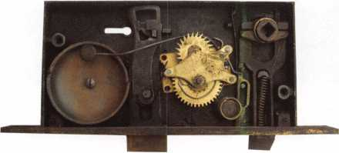

The Buck & McRoberts mortise lock was an interesting find. I've never heard of this name or the Alarm Lock Works name on the other side of the lock. It isby Isaac N. Buck of Elgin, IL. Inter­ested readers can look this up on the patent web site (uspto.gov).

The key-operated mechanism is not very sophisticated, as you can tell by the bit key that came with it. However, the lock is odd because it contains a bell with a winding mechanism. You use a key similar to a clock key to wind it. The winding key goes around a square post.

Once wound, you can set the lock to operate silently, or for oper­ation to trip the alarm bell by using the thumbturn that engages in the square hole of the hub, near the edge of the door. When the alarm is engaged, the bell goes off whenever the latch is retracted.

The four large holes in the front below the deadbolt are appar­ently to let the sound carry better.

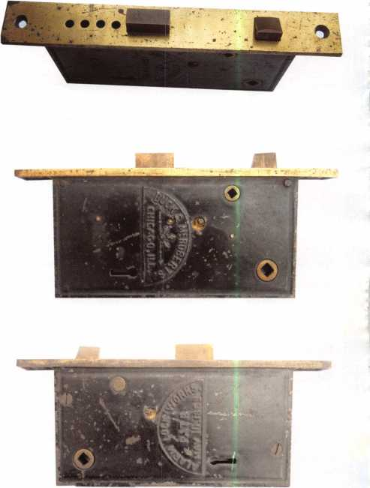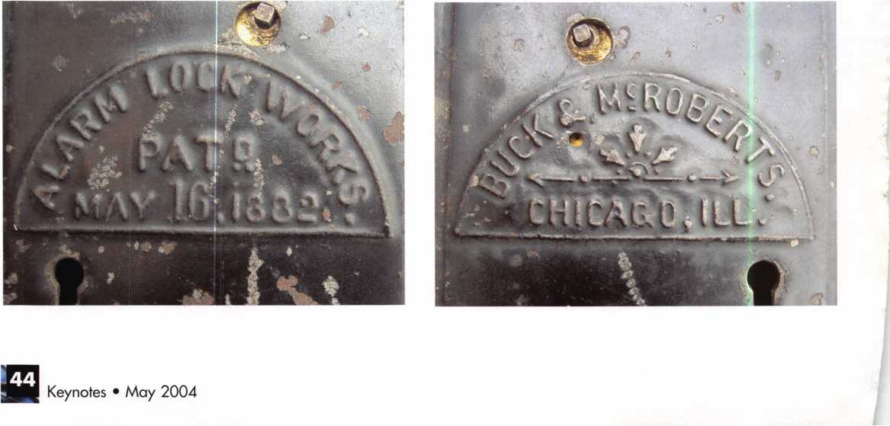

The 0afe and Vault Technicians gLssociataion  
(Qonoention and Trade ^hom

March Lt—*12*, *200*S

***Hyatt Regency, Lexingten***



tv.— —

never been more important for us safe technicians. Let me tell ya, you  
gotta stay aware of what today's top safe distributors and manufacturers  
are putting out there. It's crucial to making a humdinger of a purchasing  
decision, buddy. And another thing, time is of the essence when it  
comes to education. New things pop up every day, Daddy-O, and that  
makes top-notch safe classes as good as gold. The only chance to get  
world-class education and meet with the industry's top distributors  
and manufacturers is the SAFETECH Convention and Trade Show.

Boy, is it swell! SAFETECH 2005 offers you a chance to meet with  
potential customers and bolster business in ways you never thought  
possible. Discover the safes of tomorrow! Gee whiz, jump and jive  
your way into Safetech 2005, and you'll be part of our knock 'em,  
sock'em show of all shows!!

***Safetech Cieite beautiful Lexington, Kentucku!***

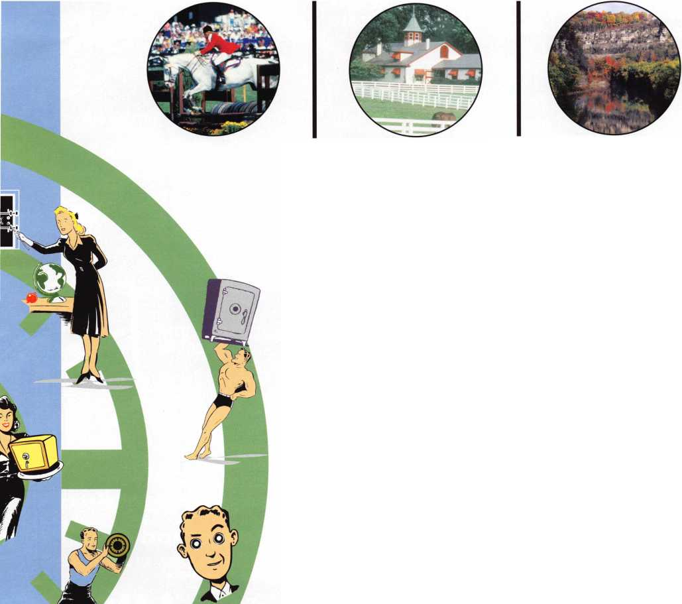

R3@© Bflsws (aaca

...you can get the factory transponder tool for less than the cost of doing one key per month?

Say "YES" to $100 phone calls.

You're^euerJqjf^yourJown... TolliFreelfechnicai Support ■KlT800-3l42-5080 i

**younlkev^to^Unlocking Ford/Ma;**

**Transponder Profits.**

**:da**

"I've lost my Taurus keys... can you make me a new set?"

NGS STAR XL CAN

Locksmith 8008LXLC

How much of your money have you sent to the local Ford Dealer?

Did you Know...

...the Dealers charge an average of $100 per transponder key?

**CAN VIM**

**81201L**

**Use what the Dealers use for complete  
coverage on ALL Ford/Lincoln-Mercury and  
Mazda vehicles equipped with transponder  
keys. The NGS XL CAN offers complete  
transponder coverage including CAN protocol**

**and the ability to clear ALL Diagnostic Service Codes.**

**2004 Software Update and CAN Vehic Interface Module now available.**

^v‘vV

***USA***

**HICKO**

**New Generation STAR XL CAP Transponder Programmei**

**© Waekon/Hickok Inc. 2004 All rights reserved.**

**INCORPORAT**

